# Improvement Title

QXY-15720 - To remove Issues from Help menu and rename Report Bug option

# Revision History

| Author | Change Description | Ver. | Date | Approved By |
| --- | --- | --- | --- | --- |
| Bharath | Initial Draft | 1.0 | 18/10/2021 | Ramesh K |

# Change Description

**Change1:**

* To hide/remove 'Issues' link from help menu

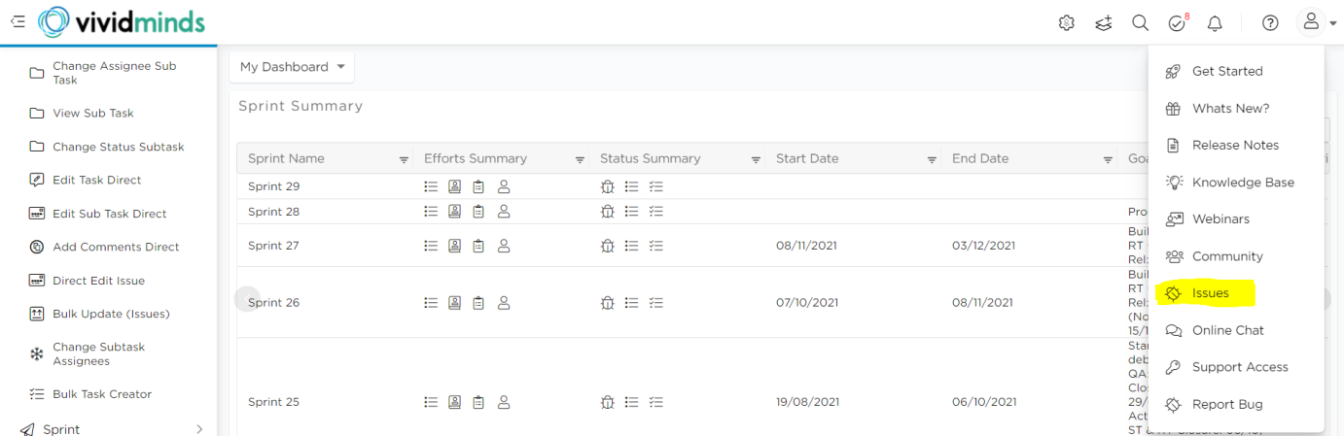

**Change2:**

* Rename 'Report a Bug' to 'Feedback/Issue'
* Change icon similar to feedback instead of bug icon

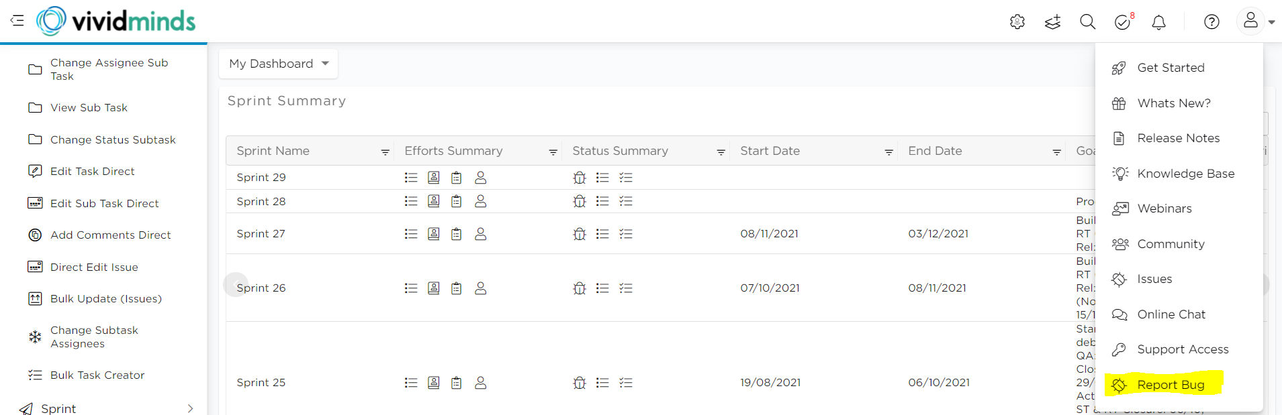

**Change3:**

* Add sub-menu as 'Consultation Call' with icon related to meetings.
* When clicked redirect to link ‘https://meetings.hubspot.com/quixy/platform-consultation-call' in a new tab
* The above added new sub-menu shall be visible only to 'organization admin' user and account license-type is 'Self Sign Up'

# Purpose

The users are getting confused with both Issues and Report Bug, which are serving the same. As Userback is more user-friendly we want to continue with it to capture both Feedback and issues.

Purpose of change3 is for easy navigation for self-signup users to contact our sales team.

# Screenshots:

Not Required

# Impact Verification:

Current change shall reflect in all accounts for following type of users

1. Account Admin - Change1, Change2, Change3
2. Workspace Admin - Change1, Change2
3. User - Change1, Change2

---END OF THE DOCUMENT---