Create Windows 10 installation USB with Media Creation Tool

This way works for legacy BIOS and UEFI boot.

To create a Windows 10 installation USB with Media Creation Tool, first you need to prepare a PC with available internet connected, a writable USB disk with at least 8 GB (If you use a USB with 4 GB, it doesn't work.). Then follow the steps below to download Media Creation Tool and create a bootable USB drive.

1. Open [Microsoft Windows 10 download site](https://www.microsoft.com/en-us/software-download/windows10). <https://www.microsoft.com/en-in/software-download/windows10>

2. Click on the **"Download tool now"** button under Create Windows 10 installation media. And save the MediaCreationTool.exe file to your PC device.

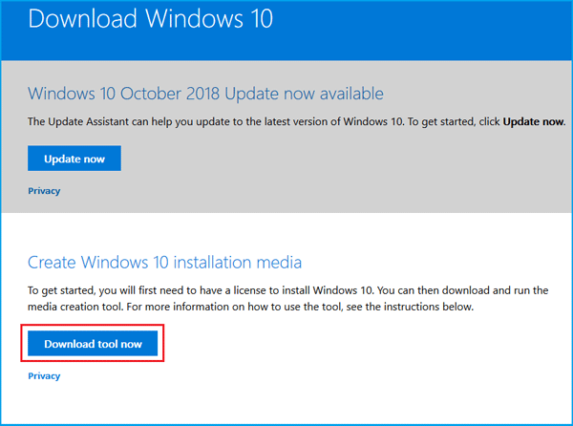

3. Right-click on the "MediaCreationTool.exe" file, and then select **"Run as Administrator"**.

4. After Getting a few things ready, click on **"Accept"** button.

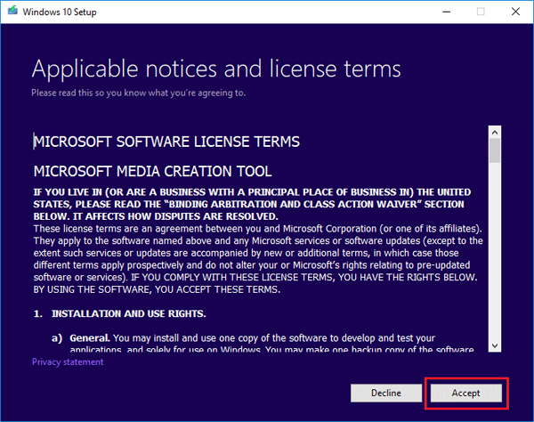

5. What do you want to do?

Select the option**"Create installation media (USB flash drive, DVD, or ISO file) for another PC"**, and then click on **"Next"**.

If you want to directly upgrade your Windows 7/8.1 PC to Windows 10, you can select the option **"Upgrade this PC now"**.

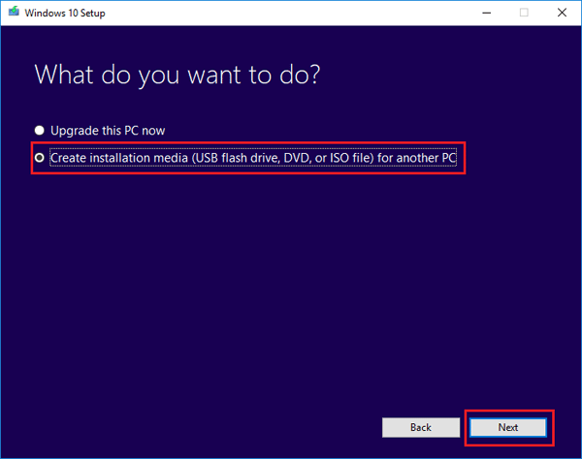

6. Select the language, architecture, edition, and then click on **"Next"**.

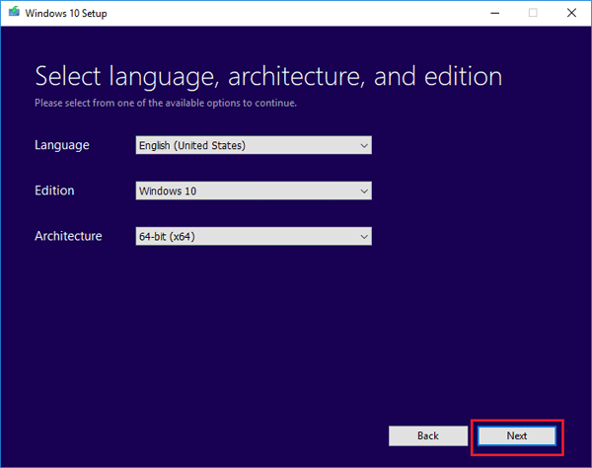

7. Choose which media to use. Select **"USB flash drive"** option.

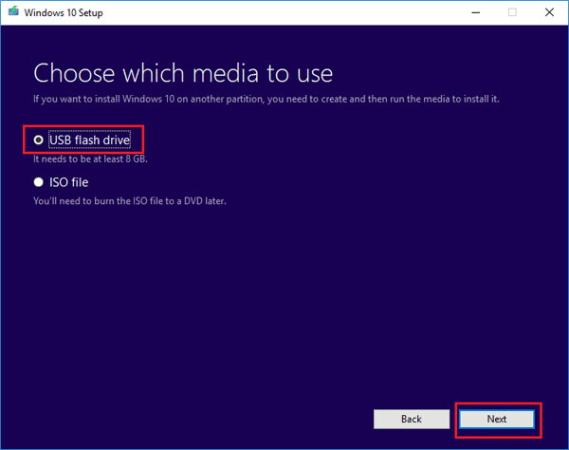

Insert a Writable USB into this PC, and click on **"Next"**.

The USB must be at least 8 GB. Remember to back up all the important data on it, as all the data on it will be erased to create a Windows 10 bootable USB drive.

If you only want to download the ISO file to this PC, you can select the option "ISO file" to download the Windows 10 ISO file on this PC to [create a Windows 10 bootable USB drive from ISO file](https://www.cocosenor.com/articles/windows-10/two-ways-to-create-a-windows-10-bootable-usb-drive-for-free.html#way-2), but you will need to burn this ISO file to a USB or DVD with burner.

8. Select your USB flash drive and click on **Next**.

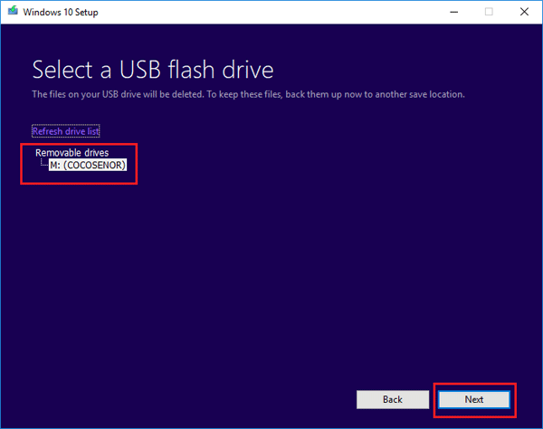

9. And then the Windows 10 downloading process begin. It will take some time to download Windows 10, please wait patiently. During this process, you can feel free to use this PC, such as watch movie or listen to music.

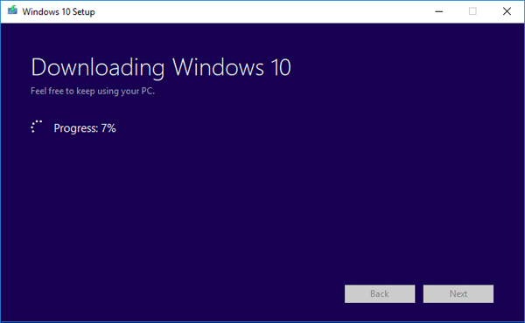

10. After downloading, your USB flash drive is ready, click on **Finish**. And then you can take this Windows 10 bootable USB drive to clean install Windows 10 on your target PC.

