

**Work Smart. Achieve More.**

System Requirement Specifications

**Human Resources Management System – Transfers and Promotions**

**Karnataka Vikas Grameena Bank**







**Contents**

1.0. Revision History: 4

2.0. Document Authorship and Approval: 4

3.0. Expected Process (TO-BE) 5

3.1. Transfer and Promotions: 5

3.1.1. Transfer: 5

3.1.1.1. Use Case: Transfer application request initiation 6

3.1.1.2. Use Case: Transfer Application Request Approval/ Rejection. 9

3.1.1.3. Use Case: General Transfer Parameter’s configuration. 10

3.1.1.4. Use Case: General Transfer Parameter’s configuration Approval/Return/Rejection 13

3.1.1.5. Use Case: Transfer Request Initiation 14

3.1.1.6. Use Case: Transfer Request Approval/Return/Rejection 16

3.1.1.7. Use Case: Transfer Modification Request initiation 22

3.1.1.8. Use Case: Transfer Modification Request Approval/Return/Rejection 24

3.1.1.9. Use Case: Transfer Cancellation Request initiation 26

3.1.1.10. Use Case: Transfer Cancellation Request Approval/Return/Rejection 28

3.1.1.11. Use Case: Staff Transfer in Head Office, request initiation. 30

3.1.1.12. Use Case: Staff Transfer in Head Office, Request Approval/Return/Rejection. 32

3.1.1.13. Use Case: Administrative Order for Temporary Responsibilities, request initiation. 34

3.1.1.14. Use Case: Administrative Order for Temporary Responsibilities, Request Approval/ Return/ Rejection. 36

3.1.1.15. Use Case: Administrative Order for Temporary Responsibilities Cancellation request initiation 38

3.1.1.16. Use Case: Administrative Order for Temporary Responsibilities Cancellation request Approval/ Rejection. 40

3.1.1.17. Functional User Stories 42

3.1.2. Promotions 48

3.1.2.1. Use Case: Summary Report of Branch Category 48

3.1.2.2. Use Case: Report of Branch Category according to their Advance and Business Criteria 51

3.1.2.3. Process Flow 54

3.1.2.4. Use Case: Configuration of Man Power Allotment according to Branch Category 55

3.1.2.5. Functional User stories for man power configuration 59

3.1.2.6. Use Case: Man power Allotment Report 59

3.1.2.7. Use Case: Report of Man Power Assessment 67

3.1.2.8. Use Case: Seniority List Report 79

3.1.2.9. Use Case: List of employee who is eligible for promotion Report 81

3.1.2.10. Use Case: Upload Final Promotion List 92

3.1.2.11. Functional User stories for Final Promotion List 95

3.1.2.12. Use Case: Generate Promotion Intimation letter for the promoted employee 95

# Revision History:

|  |  |  |  |
| --- | --- | --- | --- |
| **Version** | **Author** | **Date** | **Change Description** |
| v1.1 | Transfers- Shivadath Kumar | 05/12/2023 | Initial Draft |
| v1.1 | Promotions- Priyanka Gupta | 05/12/2023 | Initial Draft |
| v1.2 | Promotions- Priyanka Gupta | 19/12/2023 | Change 3.1.2.1., 3.2.1.8., 3.1.2.12. |
| v1.2 | Transfers- Shivadath Kumar | 20/12/2023 | Changes in Below Sections:  3.1.1.1, 3.1.1.2, 3.1.1.5, 3.1.1.6, 3.1.1.7, 3.1.1.10, 3.1.1.12 |

# Document Authorship and Approval:

|  |  |  |  |  |
| --- | --- | --- | --- | --- |
| **Version** | **Author** | **Reviewed by** | **Approved by** | **Remarks** |
| v1.1 | Transfers- Shivadath Kumar | Ramesh Kenche |  |  |
| v1.1 | Promotions- Priyanka Gupta | Ramesh Kenche |  |  |
| v1.2 | Promotions- Priyanka Gupta | Ramesh Kenche |  |  |
| v1.2 | Transfers- Shivadath Kumar | Ramesh Kenche |  |  |

# Expected Process (TO-BE)

## Transfer and Promotions:

### **Transfer:**

**Definition**: The Transfer and Promotions module is an integral component of the HRMS application tailored for Karnataka Vikas Grameena Bank. This module is designed to streamline and automate the management of all types of Transfers in KVGB.

**Purpose**: The primary purpose of the Transfer and Promotions module is to enhance the efficiency and transparency of staff’s Transfers management. It aims to simplify the process of Transfer requests while ensuring compliance with bank policies and regulatory requirements.

**Types of Transfers in KVGB:** The following are the types of transfers in KVGB and the same are accessible through this module:

1. General Transfer
2. Transfer Request by Staff

The "General Transfer" module is designed to facilitate KVGB HR team in initiating general transfer requests in accordance with KVGB regulations. General transfers occur annually, specifically in the first quarter (April, May & June), ensuring a systematic and organized approach to employee transfers. The purpose is to enable HR to efficiently manage the end-to-end process of general transfers, optimizing the allocation of staff in KVGB across various office branches within KVGB Bank.

The "Transfer on Staff Request" feature in KVGB HRMS enables staff to initiate transfer requests between different offices within KVGB. This functionality provides employees with the opportunity to request a transfer to a different branch office or regional office. The approval of such requests is subject to management discretion, ensuring a balanced and strategic approach to staff movement. The purpose is to offer employees the flexibility to seek transfers based on personal or professional considerations, contributing to a dynamic and responsive work environment within KVGB.

**Note**: Preparation and circulation of General Transfer and Request Transfer circular/note is out of HRMS

**Note**: The determination of staff relocation to specific branches, whether for General transfer or Request Transfer is beyond the scope of HRMS.

#### Use Case: Transfer application request initiation

**Users or Roles:** ALL KVGB Staff.

**Goal of the requirement:** UserShould be able to initiate Transfer application request.

**Pre-Conditions:**

1. The user must be having appropriate access rights within HRMS to initiate Transfer application request.

**Basic Flow:**

1. User logs into the HRMS solution successfully.
2. User navigates to the Transfers → Transfer application from menu and upon click on Transfer application, System should open a new window with the below form.

|  |  |  |  |  |
| --- | --- | --- | --- | --- |
| **#** | **Field Name** | **Element** | **Property** | **Remarks/Validation** |
| 1 | Transfer Request ID* | Alpha Numerical | Auto Populate | **Note**: Should Auto Generate |
| 2 | Date* | Calendar | Auto fetch | **Note**: Auto Fetch Current Date |
| 3 | EPF Number* | Numerical | Read Only | **Note**: Should Auto Populate |
| 4 | Staff Name* | Text | Read Only | Should Auto Fetch from User Details of EPF Number entered in Form Field no.3 |
| 5 | Staff Type* | Text | Read Only | Should Auto Fetch from User Details of EPF Number entered in Form Field no.3 Example: Employee or Officer |
| 6 | Cadre* | Text | Read Only | Should Auto Fetch from User Details of EPF Number entered in Form Field no.3  **Note**: Should appear for only Officer Staff Type |
| 7 | Designation* | Text | Read Only | Should Auto Fetch from User Details of EPF Number entered in Form Field no.3 |
| 8 | DOB* | Calendar | Read Only | Should Auto Fetch from User Details of EPF Number entered in Form Field no.3 |
| 9 | Age* | Numerical | Read Only | Should Auto Fetch from User Details of EPF Number entered in Form Field no.3 |
| 10 | Gender* | Text | Read Only | Should Auto Fetch from User Details of EPF Number entered in Form Field no.3 |
| 11 | Date of Joining the Bank* | Calendar | Read Only | Should Auto Fetch from User Details of EPF Number entered in Form Field no.3 |
| 12 | Qualification* | Text | Input |  |
| 13 | Proficiency in computers* | Text | Input |  |
| 14 | Current Address* | Text | Read Only | Should Auto Fetch from User Details of EPF Number entered in Form Field no.3 |
| 15 | Permanent Address* | Text | Read Only | Should Auto Fetch from User Details of EPF Number entered in Form Field no.3 |
| 16 | Current Branch DPD* | Numerical | Read Only | Should Auto Fetch from User Details of EPF Number entered in Form Field no.3 |
| 17 | Current Branch Name* | Text | Read Only | Should Auto Fetch from User Details of EPF Number entered in Form Field no.3 |
| 18 | Serving in Current Branch from Date* | Calendar | Read Only | Should Auto Fetch from User Details of EPF Number entered in Form Field no.3 |
| 19 | Time Period of Service in Current Branch* | Alpha Numerical | Read Only | Should Auto Fetch from User Details of EPF Number entered in Form Field no.3 Example: 1 Year 08 Months or 07 Months etc. |
| 20 | Posting to the current branch is General or Request Transfer* | Text | Input/ Read Only | **Note**: if we have user record in place at our end, system should auto populate from user details or and if we don’t have user record at our end, system should allow user to input. |
| 21 | Regional Office of Current Branch* | Text | Read Only | Should Auto Fetch from User Details of EPF Number entered in Form Field no.3 |
| 22 | Requesting Transfer to (Section and Grid) * | | | Below note should show to all the users involved in request  **Note**: Mention names of 3 Branches in Different Centres/ Taluks/ Districts in priority wise. |
| 22.1 | Requesting Branch DPD* | Numerical | Input |  |
| 22.2 | Requesting Branch Name* | Text | Read Only | Should Auto Fetch from as per the DPD number mentioned in 22.1 |
| 22.3 | Regional Office of requesting Branch* | Text | Read Only | Should Auto Fetch from as per the DPD number mentioned in 22.1 |
| 22.4 | Time Period of Service in the past at the Branches/Offices put together in the premises of Regional Office now requested for* | Alpha Numerical | Read Only | **Note**: System should Auto populate as per the DPD number mentioned in 22.1 |
| 23 | Reasons for Request Transfer* | Text | Input |  |

**Note:** Field names with (*) Asterisk symbol is mandatory, rest is optional.

1. User will fill the required details in Transfer application request form and clicks on submit, System should display a toaster message “Transfer application submitted.”
2. The request goes through a defined approval process.

**Post Conditions:**

1. After submission, the request should be updated with the status at the back end.
2. The system should maintain an audit trail and User actions w.r.to requests.
3. Details of Requests should be updated in Data Base for reporting Purpose.

**Business Rules and Validations:**

1. Initiator should not be able to see the status of the request.
2. This request function should not appear in HRMS for staff above Scale III- Officers.
3. While updating the branch priority details by staff, Staff should not be allowed to add the branch DPD in which he served earlier and should pop up error message stating the reason for restricting the user to add branch DPD.
4. User should be allowed to submit transfer application request only once in a timeframe as per user story- TRF-01.

**Assumptions:** NIL

**Constraints:** NIL

**Workflow**:

* Branch Staff → BM → RO M & SM → RM → HO OA & AM Core PHRDD- To be removed and non-blocker for live → HO M & SM Core PHRDD → HO PHRDD CM.
* Branch Manager & RO staff → RO M & SM → RM → HO OA & AM Core PHRDD → HO M & SM Core PHRDD → HO PHRDD CM.
* RM & HO CM (Division Heads apart from Core PHRDD) → HO OA & AM Core PHRDD → HO M & SM Core PHRDD → HO PHRDD CM- To be removed and non-blocker for live
* *HO Staff apart from Core PHRDD Team → Division Head (CM)→ HO OA & AM Core PHRDD → HO M & SM Core PHRDD → HO PHRDD CM.*
* *HO Core AM/M PHRDD → HO Core SM PHRDD → HO Core CM PHRDD*
* *HO Core SM PHRDD → HO Core AM & M PHRDD → HO Core CM PHRDD*
* HO CM PHRDD → HO OA & AM Core PHRDD → HO M & SM Core PHRDD → GM- To be removed and non-blocked for live

#### Use Case: Transfer Application Request Approval/ Rejection.

**Users or Roles:** Branch Manager, RO Manager PHRDD, RO Senior Manager PHRDD, Regional Manager, HO Office Assistant Core PHRDD, HO Assistant Manager Core PHRDD, HO Manager Core PHRDD, HO Senior Manager Core PHRDD, HO Chief Manager Core PHRDD.

**Goal of the requirement:** UsersShould be able to approve or Reject the Transfer application request initiated by staff.

**Pre-Conditions:**

1. The user is a designated Approving Authority with the appropriate permissions and accesses configured in system to Approve, Return or Reject the request.
2. There is at least one pending request awaiting for approval at the approver level.

**Basic Flow:**

1. The Approving Authority logs into the HRMS application.
2. The Approving Authority navigates to the task notifications to click on respective task stating "Received “Staff Name” Transfer application request for your action.”
3. The approving authority clicks on the request that is displayed in the notification/task tab for review and action.
4. The approving authority examines the staff transfer details in the request and based on their review, the authority chose to perform the action Approve/Return/Reject.

**Alternate Flow:**

1. The Approving Authority logs into the HRMS application.
2. User navigates to the Transfers→ Transfer Applications from menu and upon click on Transfer Application request approvals, System should open a new window and list out pending transfer applications for approval at his end.
3. The authority selects the pending Transfer application request for review.

**Post Conditions:**

1. If the request is approved, Request should be updated with status as approved at back end and move to next approval level.
2. If the request is rejected, Request should be updated with status as rejected at back end.
3. System should update the status of the request (e.g., Approved or Rejected) based on the approver's decision along with the remarks/Comments of the approving user.

**Business Rules and Validations:**

1. Initiator should not allow to know the request status, approver comments and remarks.
2. At all approver levels, Users should be able add their comments/ Remarks.
3. The system should maintain an audit trail of approval decisions, including timestamps and the identities of approvers.
4. Details of requests should be updated in Data Base for reporting Purpose.

**Assumptions:** NIL

**Constraints:** NIL

#### Use Case: General Transfer Parameter’s configuration.

**Users or Roles:** HO Office Assistant Core PHRDD, HO Assistant Manager Core PHRDD, HO Manager Core PHRDD.

**Goal of the requirement:** UserShould be able to initiate General Transfer Configuration Request.

**Pre-Conditions:**

1. The user must be having appropriate access rights within HRMS for configuration.
2. The user must possess knowledge of process, regulations, and circular details related to the configuration of General Transfer parameters

**Basic Flow:**

1. User logs into the HRMS solution successfully.
2. User navigates to the Transfers → General Transfer Configuration from menu and upon click on General Transfer Configuration, System should open a new window with the below form.

|  |  |  |  |  |
| --- | --- | --- | --- | --- |
| **#** | **Field Name** | **Element** | **Property** | **Remarks/Validation** |
| 1 | Circular Reference Number* | Text | Input |  |
| 2 | Circular Date* | Text | Input |  |
| 3 | Circular Effective from Date* | Date | Input |  |
| 4 | Staff Eligibility as per Cadre(Grid)* |  |  |  |
| 4.1 | Staff Type* | Dropdown | Input | **Values:**  1. Employee 2. Officer |
| 4.2 | Designation* | Dropdown | Input | Auto Fetch from User Details **Values**:   1. Office Attendant 2. Office Assistant 3. Assistant Manager 4. Manager 5. Senior Manager 6. Chief Manager 7. Assistant General Manager 8. DGM |
| 4.3 | Officer Posting as* | Dropdown | Input | **Values**:   1. Branch Manager 2. Regional Manager |
| 4.4 | Transfer Parameter(No.of Years of service in same branch)* | Numerical | Input |  |
| 5 | Circular or Process Note* | File Upload | Input |  |
| 6 | Initiator User Details* | User Details | Read Only |  |

**Note:** Field names with (*) Asterisk symbol is mandatory, rest is optional.

1. User will fill the required details in configuration form and clicks on submit, System should display a toaster message “General Transfer Parameters Configured.”
2. The request goes through a defined approval process.

**Post Conditions:**

1. After submission, the request should be updated with the status. (Example: Initiated, In Process and Pending at, Approved or Rejected).
2. The system should maintain an audit trail and User actions w.r.to requests.
3. Details of Requests should be updated in Data Base for reporting Purpose.

**Business Rules and Validations:** NIL

**Assumptions:**

1. Assume, HRMS administrators notified with transfer Policy changes if any and circular details.

**Constraints:** NIL

**Workflow:**

* HO OA/AM/M Core PHRDD → HO M/SM Core PHRDD → HO CM PHRDD

#### Use Case: General Transfer Parameter’s configuration Approval/Return/Rejection

**Users or Roles:** HO AM Core PHRDD, HO M Core PHRDD, HO SM Core PHRDD, HO CM PHRDD.

**Goal of the requirement:** UsersShould be able to Approve, Return or Reject the request initiated.

**Pre-Conditions:**

1. The user is a designated Approving Authority with the appropriate permissions and accesses configured in system to Approve, Return or Reject the request.
2. There is at least one pending request awaiting for approval at the approver level.

**Basic Flow:**

1. The Approving Authority logs into the HRMS application.
2. The Approving Authority navigates to the task notifications to click on respective task stating "Received General Transfer Parameter’s configuration request for your action.”
3. The approving authority clicks on the request that is displayed in the notification/task tab for review and action.
4. The approving authority examines the details in the request and based on their review, the authority chose to perform the action Approve/Return/Reject.

**Alternate Flow:**

1. The Approving Authority logs into the HRMS application.
2. User navigates to the Transfers→ Approval from menu and upon click on General Transfer Parameter’s configuration approvals, System should open a new window and list out pending Transfer requests for approval at his end.
3. The authority selects the pending request for review.

**Post Conditions:**

1. If the request is approved, Request should be updated with status as approved and moved to next approval level, the initiator is notified of approval.
2. If the request is rejected, the initiator should be notified of rejection with a reason.
3. If the request is returned, the request should be sent back to the selected user by approver for the necessary amendments in the request.
4. System should update the status of the request (e.g., Approved, Returned or Rejected) based on the approver's decision along with the remarks/Comments of the approving user.
5. The system should maintain an audit trail of approval decisions, including timestamps and the identities of approvers.
6. Details of request should be updated in Data Base for reporting Purpose.

**Business Rules:**

1. General Transfer Parameter’s configuration form should be updated with latest amended details after the request is closed with approval status.

**Assumptions:** NIL

**Constraints:** NIL

#### Use Case: Transfer Request Initiation

**Users or Roles:** HO Office Assistant Core PHRDD, HO Assistant Manager Core PHRDD, HO Manager Core PHRDD.

**Goal of the requirement:** UserShould be able to initiate Transfer Request.

**Pre-Conditions:**

1. The user must be having appropriate access rights within HRMS to initiate General Transfer request.

**Basic Flow:**

1. User logs into the HRMS solution successfully.
2. User navigates to the Transfers → Transfer Request from menu and upon click on Transfer request, System should open a new window with the below form.

|  |  |  |  |  |
| --- | --- | --- | --- | --- |
| **#** | **Field Name** | **Element** | **Property** | **Remarks/Validation** |
| 1 | Date* | Calendar | Auto fetch | Note: Auto Fetch Current Date |
| 2 | Transfer Details* | | | Should be able to upload in excel in format as per Business Rule.1 |
| 3 | Remarks/Comments | Text | Input |  |
| 4 | Initiator User Details* | User Details | Read Only | Initiator User Details* |

**Note:** Field names with (*) Asterisk symbol is mandatory, rest is optional.

1. User will fill the required details in Transfer Request Initiation form and clicks on submit, System should display a toaster message “Transfer request Initiated.”
2. The request goes through a defined approval process.

**Post Conditions:**

1. After submission, the request should be updated with the status. (Example: Initiated, In Process and Pending at, Approved or Rejected).
2. The system should maintain an audit trail and User actions w.r.to requests.
3. Details of Requests should be updated in Data Base for reporting Purpose.

**Business Rules and Validations:**

1. Below is the format in user will upload transfer details in Excel.

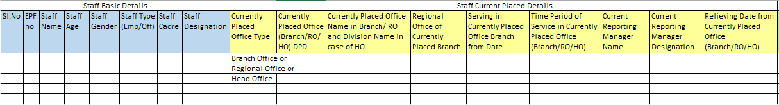

Continue…

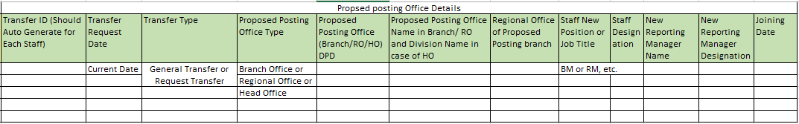

1. When a staff is getting transferred to any branch or RO/HO, the system should conduct a seniority check among available staff in the same scale in the office where the staff is being transferred. This is to guarantee that a staff member in a higher cadre is not assigned for reporting to another staff member with less Seniority in the same cadre than him/her.

System should not allow user to submit the request and should populate an error message stating “Record no- Error w.r.to Seniority Check” in any instances where above condition is not satisfied.

**Note**: Seniority is determined based on the duration of staff service in a specific scale/cadre.

1. The system should generate an error message if any female staff is assigned to a branch lacking washroom facilities, displaying the message "Record No - Female staff assigned to a branch without washroom facility.”
2. If details of staff in uploaded excel is not as per user details in master data, system should pop up an error message stating “XYZ Staff Details in uploaded excel is not matching with the user details in master data”

**Assumptions:** NIL

**Constraints:** NIL

**Workflow:**

* HO OA/AM/M Core PHRDD → HO M/SM Core PHRDD → HO CM PHRDD → GM.- to be Removed and Non-blocker for Live
* HO AM/M → HO SM → HO CM → GM- Same for Initiation, Modification and Cancelation

**Note**: Requests to be submitted separately for Employees and Officers, for employees request should terminated at GM and for Officers is at Chairman.

#### Use Case: Transfer Request Approval/Return/Rejection

**Users or Roles:** HO AM Core PHRDD, HO M Core PHRDD, HO SM Core PHRDD, HO CM PHRDD, GM.

**Goal of the requirement:** UsersShould be able to Approve, Return or Reject the Transfer request initiated.

**Pre-Conditions:**

1. The user is a designated Approving Authority with the appropriate permissions and accesses configured in system to Approve, Return or Reject the request.
2. There is at least one pending request awaiting for approval at the approver level.

**Basic Flow:**

1. The Approving Authority logs into the HRMS application.
2. The Approving Authority navigates to the task notifications to click on respective task stating "Received Transfer request for your action.”
3. The approving authority clicks on the request that is displayed in the notification/task tab for review and action.
4. The approving authority examines the staff transfer details in the request and based on their review, the authority chose to perform the action Approve/Return/Reject.

**Alternate Flow:**

1. The Approving Authority logs into the HRMS application.
2. User navigates to the Transfers→ Transfer Requests Approval from menu and upon click on Transfer Requests Approval, System should open a new window and list out pending Transfer requests for approval at his end.
3. The authority selects the pending Transfer request for review.

**Post Conditions:**

1. If the request is approved, Request should be updated with status as approved and moved to next approval level, the initiator is notified of approval.
2. If the request is rejected, the initiator should be notified of rejection with a reason.
3. If the request is returned, the request should be sent back to the selected user by approver for the necessary amendments in the request.
4. System should update the status of the request (e.g., Approved, Returned or Rejected) based on the approver's decision along with the remarks/Comments of the approving user.
5. The system should maintain an audit trail of approval decisions, including timestamps and the identities of approvers.
6. Details of request should be updated in Data Base for reporting Purpose.

**Business Rules and Validations:**

1. At each approver level, the system should offer a functionality (Return Request functionality) to send the request back to any user engaged in the process. This can be done by selecting their name and providing additional comments or remarks.
2. At all approver levels, Users should be able add their comments/ Remarks
3. Applicable for General Transfer: Upon the successful closure of a request with an approved status, a Transfer Order will be automatically generated and sent as an email attachment to the respective staff. Simultaneously, this email will also be received by the Branch Manager and Regional Manager of the current placement branch, as well as the Branch Manager and Regional Manager of the proposed placement branch. Samples of General Transfer Orders are provided below for reference.

On Transfer Order, there should be a signature of HO PHRDD Division Head and the same should fetch from the master of respective staff who is in role of HO PHRDD Division Head.

**Note**: if Staff Don’t have email id, email should be directed to email ID of current branch where staff is working

* 1. Sample 1

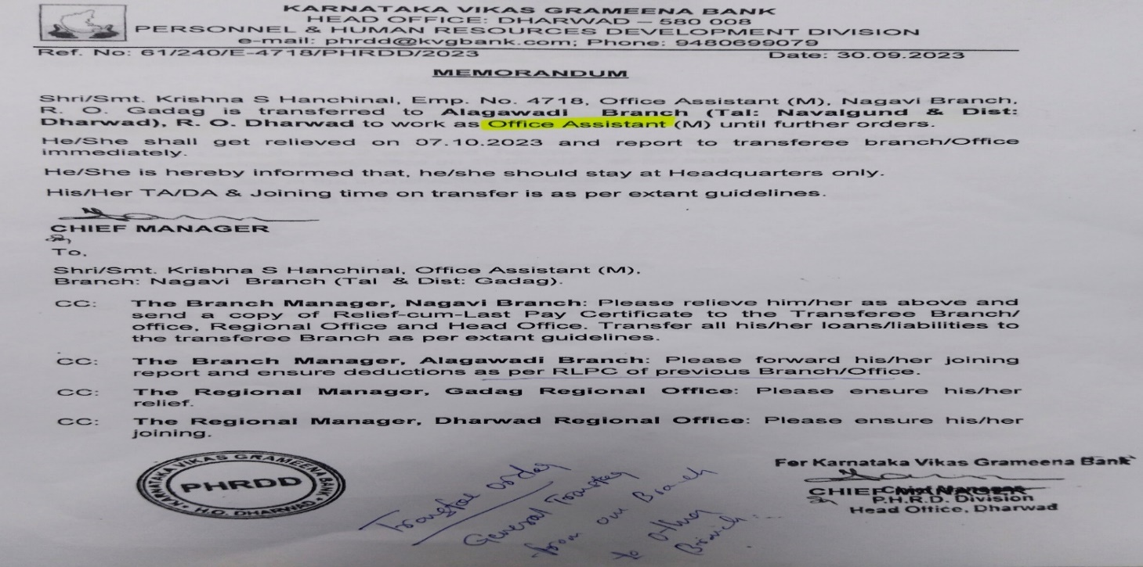

* 1. Sample 2

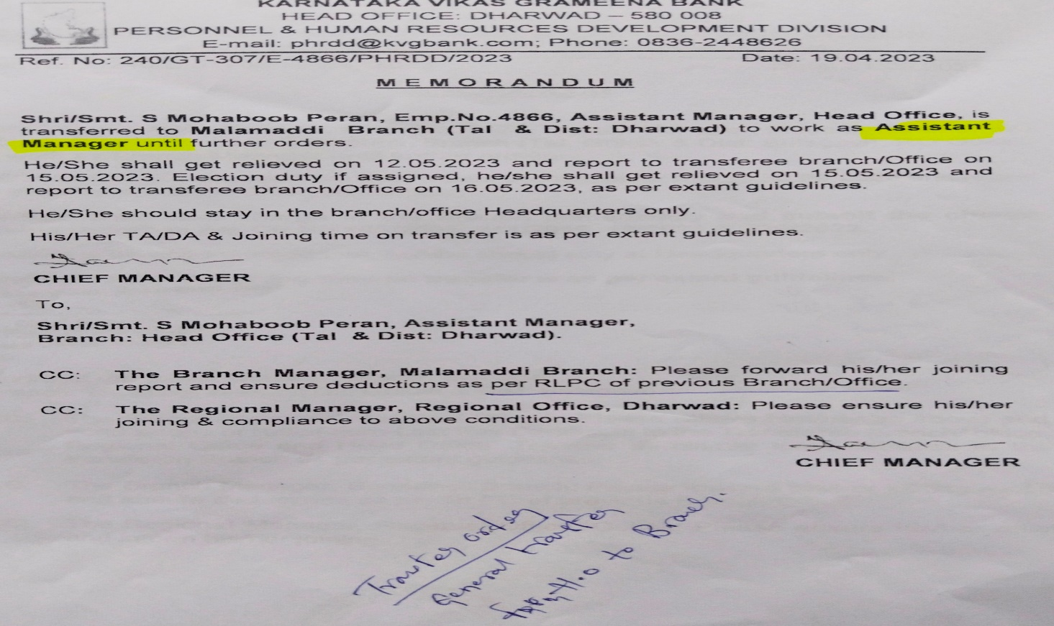

* 1. Sample 3

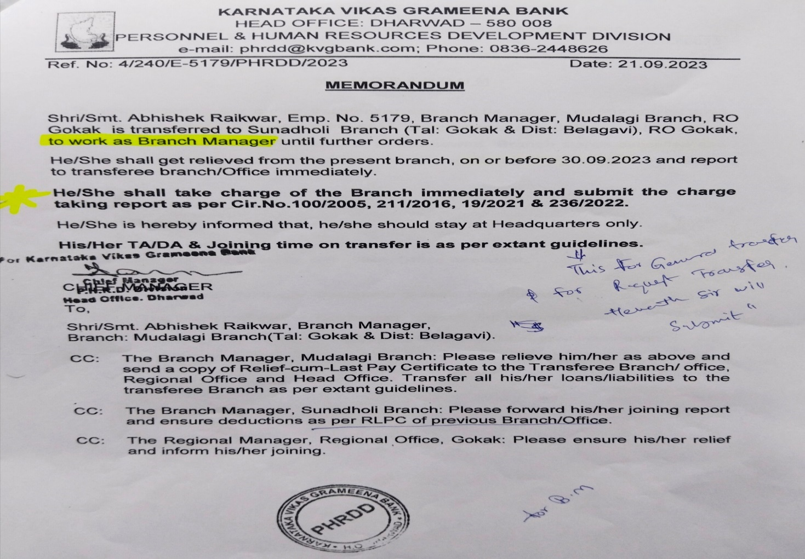

1. Applicable for Request Transfer: Upon the successful closure of a request with an approved status, a Transfer Order will be automatically generated and sent as an email attachment to the respective staff. Simultaneously, this email will also be received by the Branch Manager and Regional Manager of the current placement branch, as well as the Branch Manager and Regional Manager of the proposed placement branch. Sample of Transfer Orders is provided below for reference.

On Transfer Order, there should be a signature of HO PHRDD Division Head and the same should fetch from the master of respective staff who is in role of HO PHRDD Division Head.

**Note**: If Staff Don’t have email id, email should be directed to BM of current branch where staff is working

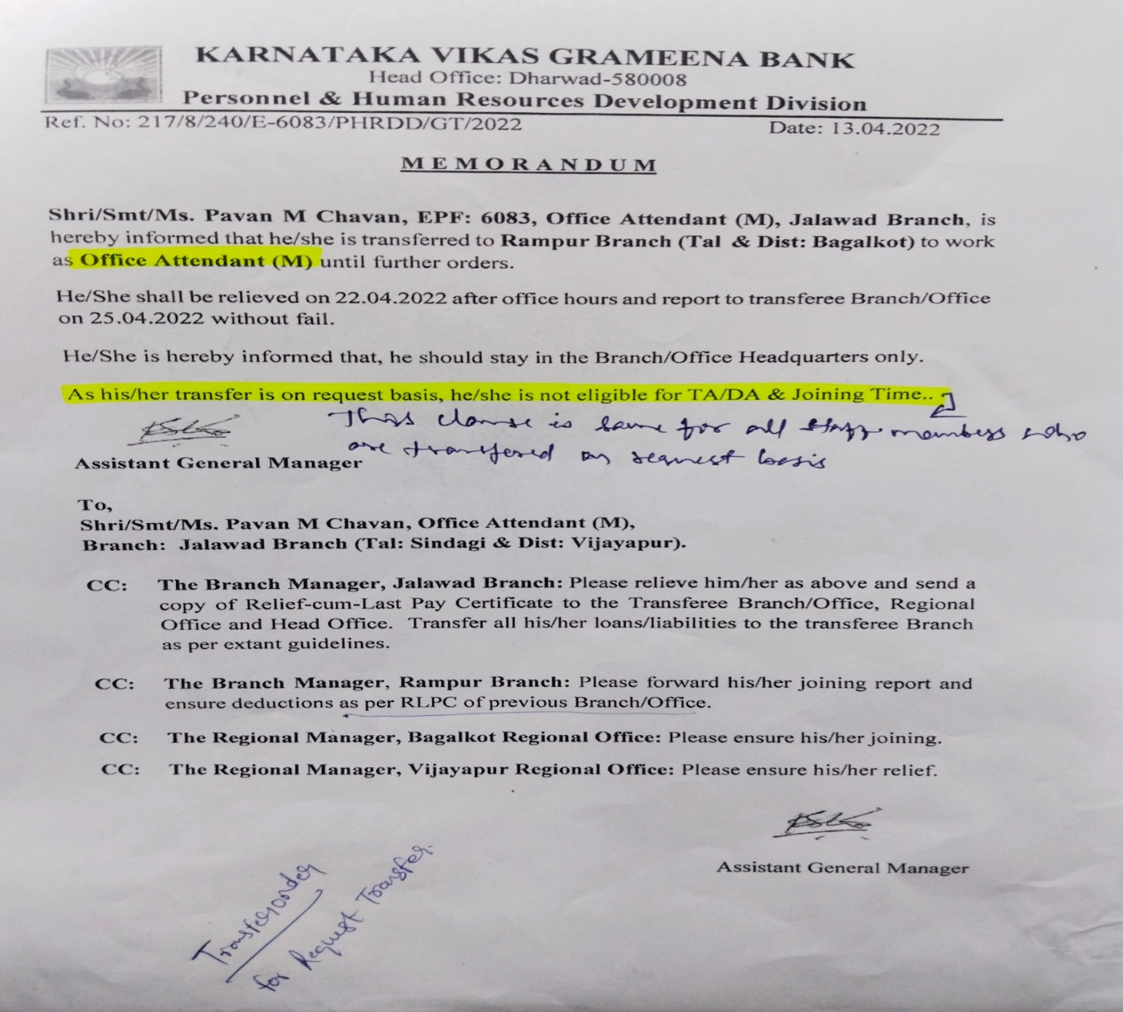

1. Applicable for Staff been Transferred to Head Office: Upon the successful closure of a request with an approved status, An Administrative Order will be automatically generated and sent as an email attachment to the respective staff. Simultaneously, this email will also be received by the Head of Division (CM) of the proposed posting division in Head Office. Sample of Administrative Orders is provided below for reference.

On Transfer Order, there should be a signature of HO PHRDD Division Head and the same should fetch from the master of respective staff who is in role of HO PHRDD Division Head

**Note**: if Staff don’t have email id, email should sent to the email ID of Head of Division of the proposed posting division in Head Office.

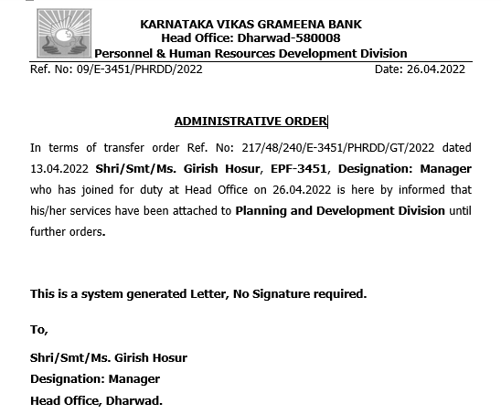

1. Transfer orders should automatically populate staff details from the uploaded excel file. It should specifically include the relieving date of the staff from their current office and the joining date of the staff in the proposed office.
2. After the request is successfully closed with an approved status, starting from the joining date specified in the transfer order, the staff should be permitted to record attendance from the proposed posting office indicated in the transfer order.
3. After the request is successfully closed with an approved status, and when the staff logs in from the proposed posting branch on the joining date, the system should verify whether the staff is on the transfer list. If confirmed, the new branch details of the staff should be updated in the employee master.

**Assumptions:**

1. Assume, User is aware that relieving letter preparation and submission to staff at currently placed branch is out of HRMS.

**Constraints:** NIL

#### Use Case: Transfer Modification Request initiation

**Users or Roles:** HO Manager Core PHRDD, HO Senior Manager Core PHRDD.

**Goal of the requirement:** UserShould be able to initiate Transfer Modification Request.

**Pre-Conditions:**

1. The user must be having appropriate access rights within HRMS to initiate Transfer modification request.

**Basic Flow:**

1. User logs into the HRMS solution successfully.
2. User navigates to the Transfers → Transfer Modification from menu and upon click on Transfer Modification, System should open a new window with the below form.

|  |  |  |  |  |
| --- | --- | --- | --- | --- |
| **#** | **Field Name** | **Element** | **Property** | **Remarks/Validation** |
| 1 | Date* | Calendar | Auto fetch | Note: Auto Fetch Current Date |
| 2 | Transfer Details* | | | Should be able to upload in excel in format as per Business Rule.1 |
| 3 | Remarks/Comments* | Text | Input |  |
| 4 | Initiator User Details* | User Details | Read Only | Initiator User Details* |

**Note:** Field names with (*) Asterisk symbol is mandatory, rest is optional.

1. User will fill the required details in Transfer modification form and clicks on submit, System should display a toaster message “Transfer modification request Initiated.”
2. The request goes through a defined approval process.

**Post Conditions:**

1. After submission, the request should be updated with the status. (Example: Initiated, In Process and Pending at, Approved or Rejected).
2. The system should maintain an audit trail and User actions w.r.to requests.
3. Details of Requests should be updated in Data Base for reporting Purpose.

**Business Rules and Validations:**

1. Below is the excel format to upload in request.

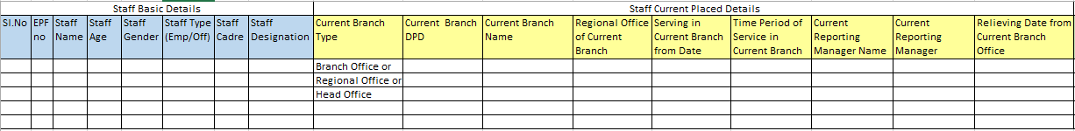

Continue….

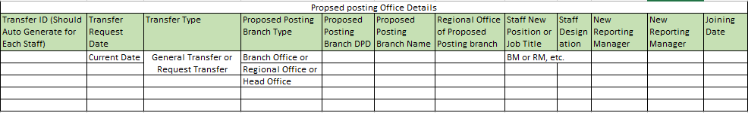

Continue….

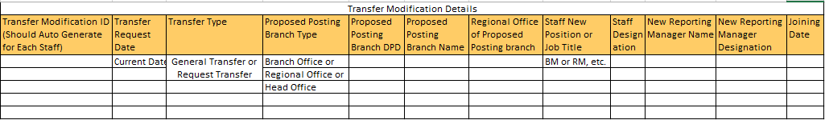

1. After the staff list is uploaded in Transfer modification request, the system should verify if the staff names in the uploaded Excel have already received a transfer order earlier in the ongoing transfer cycle (April, May, June) of the current financial year, whether it be a General Transfer Order or a Transfer Order against Request transfer.

Staff details can only be allowed for upload in the transfer modification request if they have been issued one transfer order in the current transfer cycle. Otherwise, the system should display an error message stating "*Staff Name* is not issued with any transfer order earlier in the current transfer cycle."

1. If details of staff in uploaded excel is not as per user details in master data, system should pop up an error message stating “XYZ Staff Details in uploaded excel is not matching with the user details in master data”

**Assumptions:** NIL

**Constraints:** NIL

**Workflow:**

* HO M/ SM Core PHRDD → HO CM PHRDD → GM.

**Note**: Request will get closed at GM level for Employees and Officers in HRMS.

#### Use Case: Transfer Modification Request Approval/Return/Rejection

**Users or Roles:** HO SM Core PHRDD, HO CM PHRDD, GM.

**Goal of the requirement:** UsersShould be able to Approve, Return or Reject the Transfer modification request initiated.

**Pre-Conditions:**

1. The user is a designated Approving Authority with the appropriate permissions and accesses configured in system to Approve, Return or Reject the request.
2. There is at least one pending request awaiting for approval at the approver level.

**Basic Flow:**

1. The Approving Authority logs into the HRMS application.
2. The Approving Authority navigates to the task notifications to click on respective task stating "Received Transfer modification request for your action.”
3. The approving authority clicks on the request that is displayed in the notification/task tab for review and action.
4. The approving authority examines the staff transfer details in the request and based on their review, the authority chose to perform the action Approve/Return/Reject.

**Alternate Flow:**

1. The Approving Authority logs into the HRMS application.
2. User navigates to the Transfers → Transfers Modification from menu and upon click on Transfer modification request approvals, System should open a new window and list out pending Transfer modification requests for approval at his end.
3. The authority selects the pending Transfer modification request for review.

**Post Conditions:**

1. If the request is approved, Request should be updated with status as approved and moved to next approval level, the initiator is notified of approval.
2. If the request is rejected, the initiator should be notified of rejection with a reason.
3. If the request is returned, the request should be sent back to the selected user by approver for the necessary amendments in the request.
4. System should update the status of the request (e.g., Approved, Returned or Rejected) based on the approver's decision along with the remarks/Comments of the approving user.
5. The system should maintain an audit trail of approval decisions, including timestamps and the identities of approvers.
6. Details of request should be updated in Data Base for reporting Purpose.

**Business Rules and Validations:**

1. At each approver level, the system should offer a functionality (Return Request functionality) to send the request back to any user engaged in the process. This can be done by selecting their name and providing additional comments or remarks.
2. At all approver levels, Users should be able add their comments/ Remarks
3. After the transfer modification request is successfully closed with an approved status, an automatic generation of a Transfer Order will occur. This order will be sent as an email attachment to the respective staff. Additionally, the Branch Manager and Regional Manager of both the current and proposed placement branches will receive the same email notification.

In case of business rule.6, an email should be dispatched to the Branch Manager (BM) and Regional Manager (RM) of the initially proposed posting office, as per the earlier transfer order. Additionally, the BM and RM of the proposed posting office in the transfer modification request will also receive the email, along with the BM and RM of the staff's current placement office.

**Note**: if Staff Don’t have email id, email should be directed to email id of current branch where staff is working

**Note**: For Samples Can refer 3.a, 3.b, 3.c and 4 in business rules of 3.1.1.6. Use Case: Transfer Request Approval/Return/Rejection.

1. Transfer orders should automatically populate details from the uploaded excel file containing staff information in the transfer modification request. It should specifically include the relieving date of the staff from their current office and the joining date of the staff in the proposed office.
2. With reference to transfer order against transfer modification request, if the transfer modification request of staff is closed with approved status before the joining date mentioned in the staff's earlier transfer order, the current transfer order against transfer modification request should incorporate both sets of transfer details. This includes the details of the earlier transfer, such as the proposed posting branch name and place, joining date, and staff designation, along with the modified transfer details.
3. If the transfer order for a transfer modification request is issued to the staff after they have already joined the office based on the earlier transfer order issued them in the current transfer cycle, only the modified transfer details should be specified in the transfer order and In this case, the transfer will be considered a "New General Transfer.”
4. After the request is successfully closed with an approved status, starting from the joining date specified in the transfer order and the transfer modification request for the staff, the staff should be permitted to record attendance from the proposed posting office indicated in the transfer order and transfer modification request.
5. After the request is successfully closed with an approved status, and when the staff logs in from the proposed posting branch on the joining date, the system should verify whether the staff is on the transfer list. If confirmed, the new branch details of the staff should be updated in the employee master.

**Assumptions:**

1. Assume, User is aware that relieving letter preparation and submission to staff at currently placed branch is out of HRMS.

**Constraints:** NIL

#### Use Case: Transfer Cancellation Request initiation

**Users or Roles:** HO Manager Core PHRDD, HO Senior Manager Core PHRDD.

**Goal of the requirement:** UserShould be able to initiate Transfer cancellation Request.

**Pre-Conditions:**

1. The user must be having appropriate access rights within HRMS to initiate Transfer cancellation request.

**Basic Flow:**

1. User logs into the HRMS solution successfully.
2. User navigates to the Transfers → Transfer Cancellation from menu and upon click on Transfer Cancellation, System should open a new window with the below form.

|  |  |  |  |  |
| --- | --- | --- | --- | --- |
| **#** | **Field Name** | **Element** | **Property** | **Remarks/Validation** |
| 1 | Date* | Calendar | Auto fetch | Note: Auto Fetch Current Date |
| 2 | Transfer Details* | | | Should be able to upload in excel in format as per Business Rule.1 |
| 3 | Remarks/Comments* | Text | Input |  |
| 4 | Initiator User Details* | User Details | Read Only | Initiator User Details* |

**Note:** Field names with (*) Asterisk symbol is mandatory, rest is optional.

1. User will fill the required details in Transfer cancellation form and clicks on submit, System should display a toaster message “Transfer cancellation request Initiated.”
2. The request goes through a defined approval process.

**Post Conditions:**

1. After submission, the request should be updated with the status. (Example: Initiated, In Process and Pending at, Approved or Rejected).
2. The system should maintain an audit trail and User actions w.r.to requests for accountability and compliance purposes.
3. Details of Requests should be updated in Data Base for reporting Purpose.

**Business Rules and Validations:**

1. Below is the format in user will upload transfer cancelation details in excel. Staff can mention NA for the details not available or not needed.

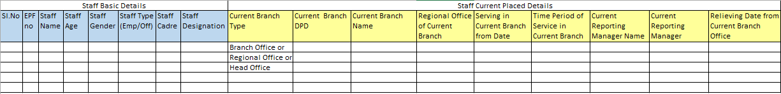

Continue….

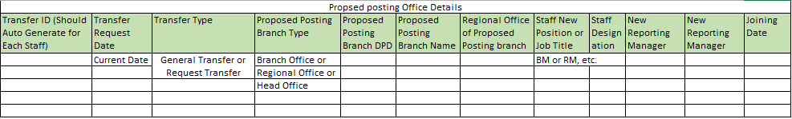

1. After the staff list is uploaded in Transfer cancellation request, the system should verify if the staff names in the uploaded Excel have already received a transfer order earlier in the ongoing transfer cycle (April, May, June) of the current financial year, whether it be a General Transfer Order or a Transfer Order against request transfer.
2. If details of staff in uploaded excel is not as per user details in master data, system should pop up an error message stating “XYZ Staff Details in uploaded excel is not matching with the user details in master data”

**Assumptions:** NIL

**Constraints:** NIL

**Workflow:**

* HO SM Core PHRDD → HO CM PHRDD → GM.

**Note**: Request will get closed at GM level for Employees and at Chairman Level for Officers.

#### Use Case: Transfer Cancellation Request Approval/Return/Rejection

**Users or Roles:** HO SM Core PHRDD, HO CM PHRDD, GM.

**Goal of the requirement:** UsersShould be able to Approve, Return or Reject the Transfer cancellation request initiated.

**Pre-Conditions:**

1. The user is a designated Approving Authority with the appropriate permissions and accesses configured in system to Approve, Return or Reject the request.
2. There is at least one pending request awaiting for approval at the approver level.

**Basic Flow:**

1. The Approving Authority logs into the HRMS application.
2. The Approving Authority navigates to the task notifications to click on respective task stating "Received Transfer cancellation request for your action.”
3. The approving authority clicks on the request that is displayed in the notification/task tab for review and action.
4. The approving authority examines the staff transfer details in the request and based on their review, the authority chose to perform the action Approve/Return/Reject.

**Alternate Flow:**

1. The Approving Authority logs into the HRMS application.
2. User navigates to the Transfers → Transfers Cancellations from menu and upon click on Transfer Cancellation request approvals, System should open a new window and list out pending Transfer cancellation requests for approval at his end.
3. The authority selects the pending Transfer cancellation requests for review.

**Post Conditions:**

1. If the request is approved, Request should be updated with status as approved and moved to next approval level, the initiator is notified of approval.
2. If the request is rejected, the initiator should be notified of rejection with a reason.
3. If the request is returned, the request should be sent back to the selected user by approver for the necessary amendments in the request.
4. System should update the status of the request (e.g., Approved, Returned or Rejected) based on the approver's decision along with the remarks/Comments of the approving user.
5. The system should maintain an audit trail of approval decisions, including timestamps and the identities of approvers.
6. Details of request should be updated in Data Base for reporting Purpose.

**Business Rules and Validations:**

1. At each approver level, the system should offer a functionality (Return Request functionality) to send the request back to any user engaged in the process. This can be done by selecting their name and providing additional comments or remarks.
2. At all approver levels, Users should be able add their comments/ Remarks
3. After the transfer cancellation request is successfully closed with an approved status, an automatic generation of a Transfer Order will occur. This order will be sent as an email attachment to the respective staff. Additionally, the Branch Manager and Regional Manager of both the current and proposed placement branches will receive the same email notification. Samples of Transfer Cancellation Order is provided below for reference.

On Transfer Cancellation Order, there should be a signature of HO PHRDD Division Head and the same should fetch from the master of respective staff who is in role of HO PHRDD Division Head

**Note**: If Staff Don’t have email id, email should be directed to BM of current branch where staff is working

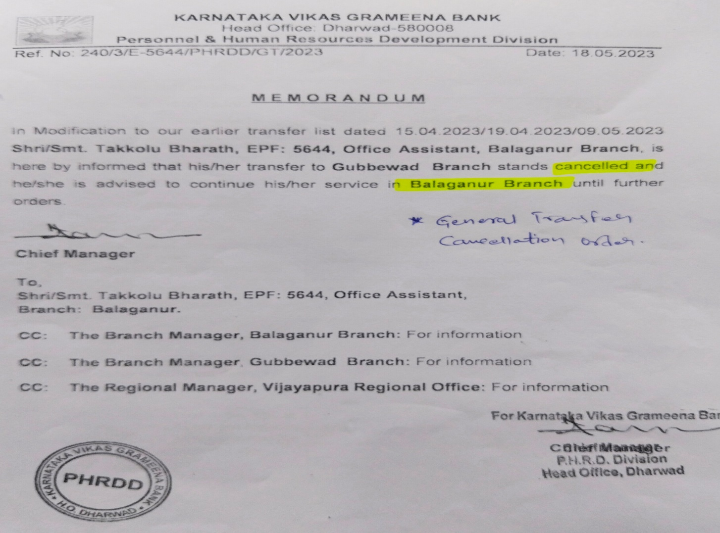

1. Transfer Cancellation order should automatically populate details from the uploaded excel file containing staff information in the transfer cancellation request.
2. After the transfer cancellation request is successfully closed with an approved status, the user should be able to register their attendance from the current office.

**Assumptions:** NIL

**Constraints:** NIL

#### Use Case: Staff Transfer in Head Office, request initiation.

**Users or Roles:** HO Manager Core PHRDD, HO Senior Manager Core PHRDD.

**Goal of the requirement:** UserShould be able to initiate the Request.

**Pre-Conditions:**

1. The user must be having appropriate access rights within HRMS for configuration.
2. The user for which request is being initiated should currently be employed at the Head Office.

**Basic Flow:**

1. User logs into the HRMS solution successfully.
2. User navigates to the Administrative Orders → Staff Transfer in Head Office from menu and upon click on Staff Transfer in Head Office, System should open a new window with the below form.

|  |  |  |  |  |
| --- | --- | --- | --- | --- |
| **#** | **Field Name** | **Element** | **Property** | **Remarks/Validation** |
| 1 | Request ID* | Alpha Numerical | Auto Populate | **Note**: Should Auto Generate |
| 2 | Date* | Calendar | Auto fetch | **Note**: Auto Fetch Current Date |
| 3 | EPF Number* | Numerical | Input |  |
| 4 | Staff Name* | Text | Read Only | Should Auto Fetch from User Details of EPF Number entered in Form Field no.3 |
| 5 | Staff Type* | Text | Read Only | Should Auto Fetch from User Details of EPF Number entered in Form Field no.3 Example: Employee or Officer |
| 6 | Cadre* | Text | Read Only | Should Auto Fetch from User Details of EPF Number entered in Form Field no.3  **Note**: Should appear for only Officer Staff Type |
| 7 | Designation* | Text | Read Only | Should Auto Fetch from User Details of EPF Number entered in Form Field no.3 |
| 08 | Gender* | Text | Read Only | Should Auto Fetch from User Details of EPF Number entered in Form Field no.3 |
| 09 | Current Division in Head Office* | Text | Input |  |
| 10 | Proposed Posting Division in Head Office* | Text | Input |  |
| 11 | Joining Date in Proposed Posting Division in Head Office* |  |  |  |

**Note:** Field names with (*) Asterisk symbol is mandatory, rest is optional.

1. User will fill the required details in configuration form and clicks on submit, System should display a toaster message “Request Initiated.”
2. The request goes through a defined approval process.

**Post Conditions:**

1. After submission, the request should be updated with the status. (Example: Initiated, In Process and Pending at, Approved or Rejected).
2. The system should maintain an audit trail and User actions w.r.to requests.
3. Details of Requests should be updated in Data Base for reporting Purpose.

**Business Rules and Validations:** NIL

**Assumptions:** NIL

**Constraints:** NIL

**Workflow:**

* HO AM- Newly Added/M Core PHRDD → HO SM Core PHRDD → HO CM PHRDD

#### Use Case: Staff Transfer in Head Office, Request Approval/Return/Rejection.

**Users or Roles:** HO SM Core PHRDD, HO CM PHRDD.

**Goal of the requirement:** UsersShould be able to Approve, Return or Reject the request initiated.

**Pre-Conditions:**

1. The user is a designated Approving Authority with the appropriate permissions and accesses configured in system to Approve, Return or Reject the request.
2. There is at least one pending request awaiting for approval at the approver level.

**Basic Flow:**

1. The Approving Authority logs into the HRMS application.
2. The Approving Authority navigates to the task notifications to click on respective task stating "Received Staff Transfer in Head Office request for your action.”
3. The approving authority clicks on the request that is displayed in the notification/task tab for review and action.
4. The approving authority examines the staff transfer details in the request and based on their review, the authority chose to perform the action Approve/Return/Reject.

**Alternate Flow:**

1. The Approving Authority logs into the HRMS application.
2. User navigates to the Administrative Orders → Staff Transfer in Head Office from menu and upon click on Approvals, System should open a new window and list out pending requests for approval at his end.
3. The authority selects the pending request for review.

**Post Conditions:**

1. If the request is approved, Request should be updated with status as approved and moved to next approval level, the initiator is notified of approval.
2. If the request is rejected, the initiator should be notified of rejection with a reason.
3. If the request is returned, the request should be sent back to the selected user by approver for the necessary amendments in the request.
4. System should update the status of the request (e.g., Approved, Returned or Rejected) based on the approver's decision along with the remarks/Comments of the approving user.
5. The system should maintain an audit trail of approval decisions, including timestamps and the identities of approvers, for accountability and compliance purposes.
6. Details of request should be updated in Data Base for reporting Purpose.

**Business Rules and Validations:**

1. At each approver level, the system should offer a functionality (Return Request functionality) to send the request back to any user engaged in the process. This can be done by selecting their name and providing additional comments or remarks.
2. At all approver levels, Users should be able add their comments/ Remarks.
3. Upon the successful closure of a request with an approved status, An Administrative Order will be automatically generated and sent as an email attachment to the respective staff. Simultaneously, this email will also be received by the Head of the Division (CM) of the staff’s current serving division in Head office and also by Head of Division (CM) of the proposed posting division in Head Office. Sample of Administrative Orders is provided below for reference.

On Administrative Order, there should be a signature of HO PHRDD Division Head and the same should fetch from the master of respective staff who is in role of HO PHRDD Division Head.

**Note**: if Staff don’t have email id, email should directed to the email ID of Head of the Division of the staff’s current serving division in Head office.

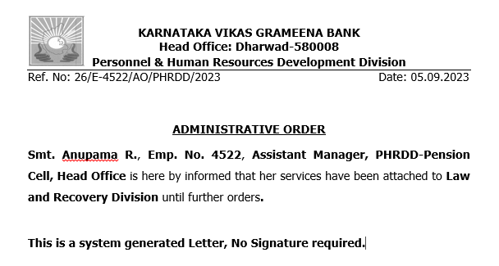

1. Administrative orders should automatically populate staff details from the details mention in request.
2. Upon the successful closure of a request with an approved status, Staff Details in Employee master should change as per the details in request.

**Assumptions:** NIL

**Constraints:** NIL

#### Use Case: Administrative Order for Temporary Responsibilities (Branch Manager), request initiation.

**Users or Roles:** HO Assistant Manager Core PHRDD, HO Manager Core PHRDD.

**Goal of the requirement:** UserShould be able to initiate the Request.

**Pre-Conditions:**

1. The user must be having appropriate access rights within HRMS for configuration.

**Basic Flow:**

1. User logs into the HRMS solution successfully.
2. User navigates to the Administrative Orders → Temporary Responsibilities from menu and upon click on Temporary Responsibilities, System should open a new window with the below form.

|  |  |  |  |  |
| --- | --- | --- | --- | --- |
| **#** | **Field Name** | **Element** | **Property** | **Remarks/Validation** |
| 1 | Request ID* | Alpha Numerical | Auto Populate | **Note**: Should Auto Generate |
| 2 | Date* | Calendar | Auto fetch | **Note**: Auto Fetch Current Date |
| 3 | EPF Number* | Numerical | Input |  |
| 4 | Staff Name* | Text | Read Only | Should Auto Fetch from User Details of EPF Number entered in Form Field no.3 |
| 5 | Staff Type* | Text | Read Only | Should Auto Fetch from User Details of EPF Number entered in Form Field no.3 Example: Employee or Officer |
| 6 | Cadre* | Text | Read Only | Should Auto Fetch from User Details of EPF Number entered in Form Field no.3  **Note**: Should appear for only Officer Staff Type |
| 7 | Designation* | Text | Read Only | Should Auto Fetch from User Details of EPF Number entered in Form Field no.3 |
| 08 | Gender* | Text | Read Only | Should Auto Fetch from User Details of EPF Number entered in Form Field no.3 |
| 09 | Currently Placed Office (Branch) DPD.* | Text | Read Only | Should Auto Fetch from User Details of EPF Number entered in Form Field no.3 |
| 10 | Currently Place Office (Branch) Name | Text | Read Only | Should Auto Fetch from User Details of EPF Number entered in Form Field no.3 |
| 11 | Regional Office of Currently Placed Branch* | Text | Read Only | Should Auto Fetch from User Details of EPF Number entered in Form Field no.3 |
| 12 | Temporary Responsibility Details (Section and Grid)* | | | |
| 12.1 | Take in Charge as* | Dropdown | Input | **Values**:   1. Branch Manager |
| 12.2 | Take in Charge from Date* | Calendar | Input |  |
| 12.3 | Take in Charge for Office(Branch) DPD* | Numerical | Input |  |
| 12.4 | Take in Charge for, Office Name (Branch)* | Text | Read Only | Should Auto Fetch as per DPD no mentioned in 13.3 |

**Note:** Field names with (*) Asterisk symbol is mandatory, rest is optional.

1. User will fill the required details in configuration form and clicks on submit, System should display a toaster message “Request Initiated.”
2. The request goes through a defined approval process.

**Post Conditions:**

1. After submission, the request should be updated with the status. (Example: Initiated, In Process and Pending at, Approved or Rejected).
2. The system should maintain an audit trail and User actions w.r.to requests for accountability and compliance purposes.
3. Details of Requests should be updated in Data Base for reporting Purpose.

**Business Rules and Validations:** NIL

**Assumptions:** NIL

**Constraints:** NIL

**Workflow:**

* HO AM/M Core PHRDD → HO M/SM Core PHRDD → HO CM PHRDD

#### Use Case: Administrative Order for Temporary Responsibilities, Request Approval/ Return/ Rejection.

**Users or Roles:** HO M Core PHRDD, HO SM Core PHRDD, HO CM PHRDD.

**Goal of the requirement:** UsersShould be able to Approve, Return or Reject the request initiated.

**Pre-Conditions:**

1. The user is a designated Approving Authority with the appropriate permissions and accesses configured in system to Approve, Return or Reject the request.
2. There is at least one pending request awaiting for approval at the approver level.

**Basic Flow:**

1. The Approving Authority logs into the HRMS application.
2. The Approving Authority navigates to the task notifications to click on respective task stating "Received Administrative Order request for your action.”
3. The approving authority clicks on the request that is displayed in the notification/task tab for review and action.
4. The approving authority examines the staff transfer details in the request and based on their review, the authority chose to perform the action Approve/Return/Reject.

**Alternate Flow:**

1. The Approving Authority logs into the HRMS application.
2. User navigates to the Administrative Orders → Temporary Responsibilities in Head Office from menu and upon click on Approvals, System should open a new window and list out pending requests for approval at his end.
3. The authority selects the pending request for review.

**Post Conditions:**

1. If the request is approved, Request should be updated with status as approved and moved to next approval level, the initiator is notified of approval.
2. If the request is rejected, the initiator should be notified of rejection with a reason.
3. If the request is returned, the request should be sent back to the selected user by approver for the necessary amendments in the request.
4. System should update the status of the request (e.g., Approved, Returned or Rejected) based on the approver's decision along with the remarks/Comments of the approving user.
5. The system should maintain an audit trail of approval decisions, including timestamps and the identities of approvers.
6. Details of request should be updated in Data Base for reporting Purpose.

**Business Rules and Validations:**

1. At each approver level, the system should offer a functionality (Return Request functionality) to send the request back to any user engaged in the process. This can be done by selecting their name and providing additional comments or remarks.
2. At all approver levels, Users should be able add their comments/ Remarks.
3. Upon the successful closure of a request with an approved status, An Administrative Order will be automatically generated and sent as an email attachment to the respective staff. Simultaneously, this email will also be received by the BM/RM of the staff’s currently placed office. Sample of Administrative Orders is provided below for reference.

On Administrative Order, there should be a signature of HO PHRDD Division Head and the same should fetch from the master of respective staff who is in role of HO PHRDD Division Head.

**Note**: if Staff don’t have email id, email should directed to the BM/RM/Head of the Division (CM) of the staff’s currently placed office.

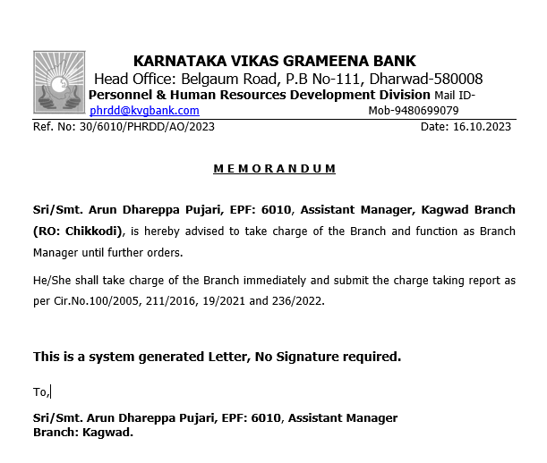

1. Administrative orders should automatically populate staff details from the details mentioned in request.
2. Upon the successful closure of a request with an approved status, Staff should be assigned with all the system authorities which are applicable for the temporary position.

**Assumptions:** NIL

**Constraints:** NIL

#### Use Case: Administrative Order for Temporary Responsibilities Cancellation request initiation

**Users or Roles:** HO Office Assistant Core PHRDD, HO Assistant Manager Core PHRDD, HO Manager Core PHRDD.

**Goal of the requirement:** UserShould be able to initiate the Request.

**Pre-Conditions:**

1. The user must be having appropriate access rights within HRMS for configuration.

**Basic Flow:**

1. User logs into the HRMS solution successfully.
2. User navigates to the Administrative Orders → Temporary Responsibilities from menu and upon click on Cancellation, System should open a new window with the below form.

|  |  |  |  |  |
| --- | --- | --- | --- | --- |
| **#** | **Field Name** | **Element** | **Property** | **Remarks/Validation** |
| 1 | Cancellation Request ID* | Alpha Numerical | Auto Populate | **Note**: Should Auto Generate |
| 2 | Date* | Calendar | Auto fetch | **Note**: Auto Fetch Current Date |
| 3 | EPF Number* | Numerical | Input | **Note**: Should Auto Populate |
| 4 | Staff Name* | Text | Read Only | Should Auto Fetch from User Details of EPF Number entered in Form Field no.3 |
| 5 | Staff Type* | Text | Read Only | Should Auto Fetch from User Details of EPF Number entered in Form Field no.3 Example: Employee or Officer |
| 6 | Cadre* | Text | Read Only | Should Auto Fetch from User Details of EPF Number entered in Form Field no.3  **Note**: Should appear for only Officer Staff Type |
| 7 | Designation* | Text | Read Only | Should Auto Fetch from User Details of EPF Number entered in Form Field no.3 |
| 08 | Gender* | Text | Read Only | Should Auto Fetch from User Details of EPF Number entered in Form Field no.3 |
| 09 | Staff Existing Temporary Responsibilities Request ID* | Numerical | Read Only | Should Auto Fetch from User Details of EPF Number entered in Form Field no.3 and user should be able to view the request details by clicking on request ID. |

**Note:** Field names with (*) Asterisk symbol is mandatory, rest is optional.

1. User will fill the required details in configuration form and clicks on “Cancel Temporary Responsibilities”, System should display a toaster message “Request Initiated.”
2. The request goes through a defined approval process.

**Post Conditions:**

1. After submission, the request should be updated with the status. (Example: Initiated, In Process and Pending at, Approved or Rejected).
2. The system should maintain an audit trail and User actions w.r.to request.
3. Details of Requests should be updated in Data Base for reporting Purpose.

**Business Rules and Validations:** NIL

**Assumptions:** NIL

**Constraints:** NIL

**Workflow:**

HO OA/AM/M Core PHRDD → HO M/SM Core PHRDD → HO CM PHRDD

#### Use Case: Administrative Order for Temporary Responsibilities Cancellation request Approval/ Rejection.

**Users or Roles:** HO AM Core PHRDD, HO M Core PHRDD, HO SM Core PHRDD, HO CM PHRDD.

**Goal of the requirement:** UsersShould be able to Approve, Return or Reject the request initiated.

**Pre-Conditions:**

1. The user is a designated Approving Authority with the appropriate permissions and accesses configured in system to Approve, Return or Reject the request.
2. There is at least one pending request awaiting for approval at the approver level.

**Basic Flow:**

1. The Approving Authority logs into the HRMS application.
2. The Approving Authority navigates to the task notifications to click on respective task stating "Received Administrative Order Cancellation request for your action.”
3. The approving authority clicks on the request that is displayed in the notification/task tab for review and action.
4. The approving authority examines the staff transfer details in the request and based on their review, the authority chose to perform the action Approve/ Reject.

**Alternate Flow:**

1. The Approving Authority logs into the HRMS application.
2. User navigates to the Administrative Orders → Temporary Responsibilities from menu and upon click on Approvals, System should open a new window and list out pending requests for approval at his end.
3. The authority selects the pending request for review.

**Post Conditions:**

1. If the request is approved, Request should be updated with status as approved and moved to next approval level, the initiator is notified of approval.
2. If the request is rejected, the initiator should be notified of rejection with a reason.
3. System should update the status of the request (e.g., Approved or Rejected) based on the approver's decision along with the remarks/Comments of the approving user.
4. The system should maintain an audit trail of approval decisions, including timestamps and the identities of approvers.
5. Details of request should be updated in Data Base for reporting Purpose.

**Business Rules and Validations:**

1. At all approver levels, Users should be able add their comments/ Remarks.
2. Upon the successful closure of a request with an approved status, An Administrative Order will be automatically generated and sent as an email attachment to the respective staff. Simultaneously, this email will also be received by the BM/RM of the staff’s currently placed office. Sample of Administrative Orders is provided below for reference.

On Administrative Order, there should be a signature of HO PHRDD Division Head and the same should fetch from the master of respective staff who is in role of HO PHRDD Division Head.

**Note**: if Staff don’t have email id, email should directed to the BM/RM/Head of the Division (CM) of the staff’s currently placed office.

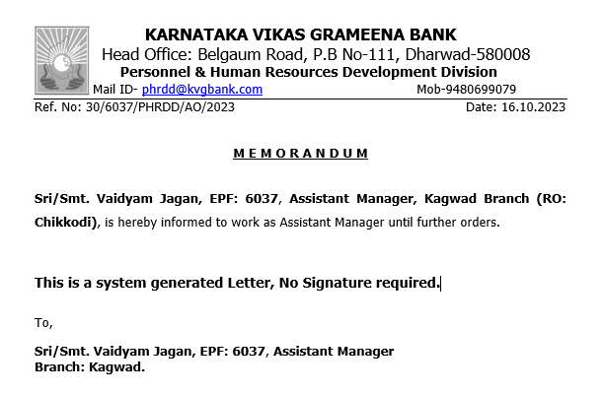

1. Administrative orders should automatically populate staff details from the details mentioned in request.
2. Upon the successful closure of a request with an approved status, Staff should be reassigned with all the system authorities which are applicable before assigning temporary responsibilities.

**Assumptions:** NIL

**Constraints:** NIL

#### Functional User Stories

|  |  |  |  |  |
| --- | --- | --- | --- | --- |
| **Id** | **Functionality** | **Role** | **Description** | **Acceptance criteria/ Remarks** |
| TRF-01 | Enabling/Activating Functionality of Transfer Requests by Staff | HO AM Core PHRDD, HO M Core PHRDD, HO SM Core PHRDD. | As a user, I should have the ability to activate/Enables the Transfer Request functionality with a specified cut-off date. So that, This enables staff to submit their transfer requests within the provided timeframe. | 1. The user should have an option to set the cut-off date when enabling or activating the transfer requests for KVGB staff. 2. Upon activation of the functionality, a notification will be dispatched to HO CM PHRDD, prompting confirmation through two options: Approve or Deny. 3. Following approval from HO CM PHRDD, a notification will be circulated to all KVGB staff, stating, "You can submit your Transfer Requests until Date: XXXX." 4. Transfer request functionality should be disabled/Deactivated after the cut-off date. |
| REQM-1 | General Transfer Parameter’s configuration request Edit/Resubmit  &  Transfer request Edit/Resubmit. &  Transfer Modification Request Edit/Resubmit.  &  Transfer Cancellation request Edit/Resubmit.  &  Staff Transfer in Head Office request Edit/Resubmit  &  Administrative Order for Temporary Responsibilities request Edit/Resubmit | HO AM Core PHRDD, HO M Core PHRDD, HO SM Core PHRDD, HO CM PHRDD. | As a user, I should have the ability to edit and resubmit the request that has been returned by the approver. So that I can make any required amendments to the request and resubmit it for the necessary approvals. | 1. The user should have a "Edit” and “Resubmit" option available for a request that has been returned by any approver. 2. User should be able to view comments/Remarks by approvers to know why the request have been returned and what are the details need to amend. 3. The system should record a timestamp of when the request was edited and resubmitted. 4. The system should send notifications to the relevant approver(s) to alert them to the resubmission of the request. 5. The system should maintain a history or audit trail of the edits and resubmissions for each request. 6. Upon resubmission, the request should follow the same approval workflow as a new request, including routing to the appropriate approver(s). |
| GTDR-01 | Report: General Transfer Due Report | HO AM Core PHRDD, HO M Core PHRDD, HO SM Core PHRDD, HO CM PHRDD. | As a user, I should be able to run the report to view and download the details of staff eligible for General Transfer in the upcoming transfer period according to configured parameters. So that, it will help in facilitating a smooth handling of the general transfer process for the staff who are due. | 1. The user should have access to the report at any given time by selecting the report. 2. Details of the staff appears in report should be as per the parameter’s mentioned in general transfer configuration. 3. The configured Transfer Period will be considered up to the 30th of June each year. All staff members completing the specified number of years according to the configuration parameters as of the 30th of June in a particular year will be eligible for transfer in that year's general transfer process. 4. Staff details in this report include    1. Staff due for general transfer.    2. Staff who have exceeded the general transfer timeline; these records should be highlighted in the report. 5. There should be filter for all the Headers in the report. 6. Input of data is from user details and majorly from employee master, branch master.   **Note**: Find the Sample Report in Reference Documents. |
| TRSR-01 | Report: Transfer Requested by Staff | HO AM Core PHRDD, HO M Core PHRDD, HO SM Core PHRDD, HO CM PHRDD. | As a user, I should be able to run the report to view and download the details of staff’s transfer application requests by selecting from and to Date. So that, it will help in facilitating a smooth handling of transfer application requests submitted by staffs. | 1. The user should have access to the report at any given time by selecting the report. 2. The report should include details of staff members who have submitted transfer application requests within the timeframe specified in user story TRF-01, regardless of whether their requests were approved or rejected. This status of staff's transfer application should be reflected in the report alongside user details. 3. There should be filter for all the Headers in the report. 4. Input of data is from user details and majorly from employee master, branch master.   **Note**: Find the Sample Report in Reference Documents no.2 |
| TSJR-01 | Report: Transferred Staff Joining Report. | HO AM Core PHRDD, HO M Core PHRDD, HO SM Core PHRDD, HO CM PHRDD | As a user, I should be able to access and download a list of transferred staff, along with their joining status in the proposed posting office on a specified date. So that, I stay informed about whether the staff members have joined the office mentioned in the proposed posting office on their scheduled joining date. | 1. The user should have access to the report at any given time by selecting the report. 2. The report includes details of staff members whose names are present in the transfer request. 3. Staff who clock in their attendance from the proposed posting office on the scheduled joining date will be marked as joined, while those who do not will be considered as not joined. 4. Below details should populate in the report and the same can be fetched from details of staff in General Transfer Request.    1. Sl.No    2. EPF no    3. Staff Name    4. Staff Designation    5. Staff Present Branch    6. Present Branch Relieving Date    7. Proposed Posting Branch Name    8. Reporting Date in Proposed Posting Branch    9. Staff Joined: Yes/No ( This will be de determined as per staff attendance) |

**Reference Documents**:

1. Below is the sample of General Transfer Due Report.

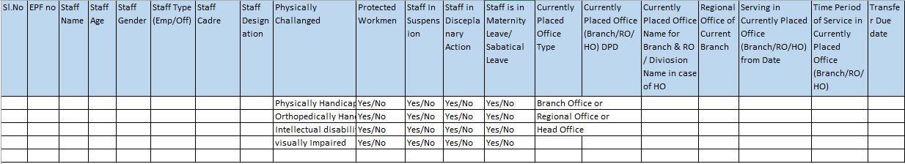

1. Below is the sample of Report: Transfer Requested by Staff

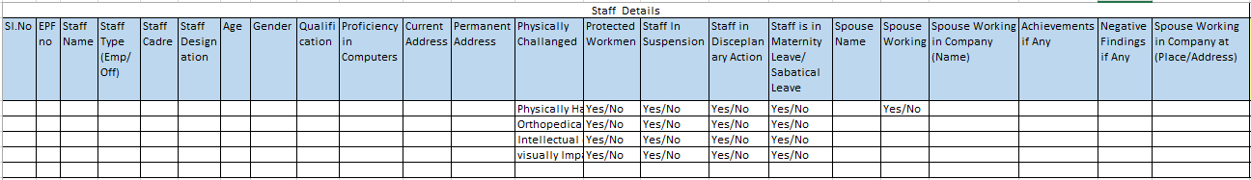

Continue…

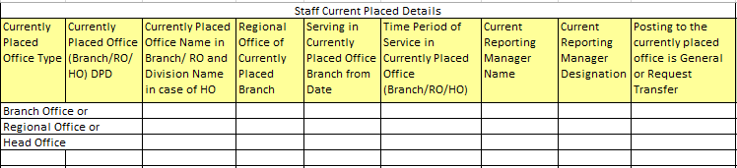

Continue…

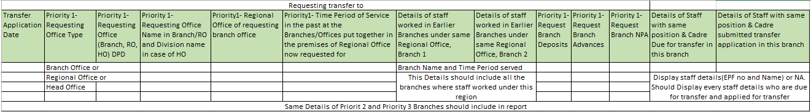

### Promotions

**Definition**: The promotion of an employee refers to the advancement of that individual to a higher-level position within the organizational hierarchy. The goal of promotions is to recognize and reward employees for their contributions, encourage career development, and motivate them to continue to excel in their roles.

**Purpose**: Employee promotions serve various purposes within KVGB, and they are an important aspect of talent management and employee development. There are different purpose of employee promotions like Recognition of Performance, Motivation and Morale Boost, Retention of Talent etc.

#### Use Case: Summary Report of Branch Category

**Definition: -** A summary or breakdown of the different categories of branches based on criteria such as Business Criteria and Advance.

**Purpose: -** The purpose of a Summary Report of Branch Category in a banking context or organizational management is multifaceted. The main purpose of Branch Category is Strategic Decision-Making, Resource Optimization etc.

**Goal of Requirement:** System should generate a report summary Branch Category Report.

**User: -** HO AM/M CORE PHRDD, HO SM CORE PHRDD, HO CM PHRDD

**Pre-conditions:**

1. User should be the permanent staff.
2. User shouldn’t be resigned, exited, suspended, retired, disable.

**Basic Flow:**

1. User logs into the HRMS solution successfully.
2. User navigates to the Transfer and Promotion from menu and upon click on Summary of Branch Category Report.
   1. System should open a new window with the below fields.

**Form Details:**

|  |  |  |  |  |
| --- | --- | --- | --- | --- |
| **#** | **Field  Name** | **Element** | **Property** | **Remarks/Validation** |
| 1. | Summary Report of the Branch Categorization | Rich Text Box | Read Only | Summary Report of the categorization. |
| 2. | Category | Text | Read Only | Data should be fetched according to business Rules. |
| 3. | Business Criteria (Amount in crores) | Text | Read Only |
| 4. | Advance Level | Text | Read Only |
| 5. | Number of Branches | Text | Read Only | * The system should display the count of the number of branches in each category based on branch criteria and the branch advance level. * The system should display the count of branches that have the same category. * For Example: - If branches ABC, PQR, and XYZ are categorized as Category A, the system should display count indicating that Category A has three branches. |

1. After filling the form, User will click on Submit Button.

**Note:** Field names with (*) Asterisk symbol is mandatory, rest is optional.

**Post Conditions:**

1. System should generate the Branch report category wise.
2. Users should be able to view and download the Branch category report.
3. Report should be download in Excel and PDF both format.

**Business Rules:**

1. The system should calculate the number of branches in each category based on branch criteria and branch advance level, utilizing the following business rules.

* In case if the Business criteria is Up to Rs.10 crore and Advance is < 6 crore, then branch should be category A.
* In case if the Business criteria is Up to Rs.10 crore and Advance is >=6 crore, then branch should be category A.
* In case if the Business criteria is above 10 crore to Up to Rs.30 crore and Advance is < 10 crore, then branch should be category B.
* In case if the Business criteria is above 10 crore to Up to Rs.30 crore and Advance is >=10 crore, then branch should be category B.
* In case if the Business criteria is above 30 crore to Up to Rs.75 crore and Advance is < 20 crore, then branch should be category C.
* In case if the Business criteria is above 30 crore to Up to Rs.75 crore and Advance is >=20 crore, then branch should be category C.
* In case if the Business criteria is above 75 crore to Up to Rs.200 crore and Advance is < 35 crore, then branch should be category D.
* In case if the Business criteria is above 75 crore to Up to Rs.200 crore and Advance is >= 35 crore, then branch should be category D.
* In case if the Business criteria is above 200 crore Advance is < 60 crore, then branch should be category E.
* In case if the Business criteria is above 200 crore and Advance is >= 60 crore, then branch should be category E.

1. Business Data as on 31st March of every year will be provided in Performance Appraisal. The system should categories as per the above guidelines.
2. System should take the input of branch criteria and Branch Advance from performance Appraisal module Achievement on March and categorize according to configured business rule.
3. Branch Criteria= Achievement on March Deposit KRA Database + Achievement on March from Configure Advance KRA Database.
4. Branch Advance = Achievement on March Configure Advance KRA Database.
5. The branch that matches the above criteria will be suitable for that category.
6. For Example: -if MUDUR Branch Business criteria is 19 crore and the advance is 11 crore then it will be category B.
7. Users can filter the required data by selecting the desired filter and entering a value at the top of the column.
8. System should display this report according to Business Rule. The reports should be the below format.

|  |  |  |  |  |  |  |  |  |  |  |  |  |  |  |  |  |  |  |  |  |  |  |  |  |  |  |  |  |  |  |  |  |  |  |  |  |  |  |  |  |  |  |  |  |  |  |  |  |  |  |  |  |  |  |  |
| --- | --- | --- | --- | --- | --- | --- | --- | --- | --- | --- | --- | --- | --- | --- | --- | --- | --- | --- | --- | --- | --- | --- | --- | --- | --- | --- | --- | --- | --- | --- | --- | --- | --- | --- | --- | --- | --- | --- | --- | --- | --- | --- | --- | --- | --- | --- | --- | --- | --- | --- | --- | --- | --- | --- | --- |
| **A SUMMARY REPORT of BRANCHES CATEGORY**   |  |  |  |  |  | | --- | --- | --- | --- | --- | | **Sr. No** | **Branch Category** | **Business Criteria**  **(AMT in Crores)** | **Advance Level**  **(AMT in Crores)** | **Number of Branches** | | 1 | Category A | Up to 10 Crores | < 6 | 04 | | 2 | Category A | Up to 10 Crores | > 6 | 04 | | 3 | Category B | Above 10 Crores & up to 30 Crore | < 10 | 80 | | 4 | Category B | Above 10 Crores & up to 30 Crore | >10 | 75 | | 5 | Category C | Above 30 Crores & up to 75 Crore | <20 | 150 | | 6 | Category C | Above 30 Crores & up to 75 Crore | >20 | 212 | | 7 | Category D | Above 75 Crores & up to 200 Crore | <35 | 35 | | 8 | Category D | Above 75 Crores & up to 200 Crore | >35 | 212 | | 9 | Category E | Above 200 Crores | <60 | 125 | | 10 | Category E | Above 200 Crores | > 60 | 55 | |

**Assumptions:**

1. Branch category should be correct configured.

**Constraints:** NIL

#### Use Case: Report of Branch Category according to their Advance and Business Criteria

**Definition: -** A Detail of breakdown of the different categories of branches based on criteria such as Business Criteria and Advance.

**Purpose: -** The purpose of a Detail Report of Branch Category in a banking context or organizational management is multifaceted.

**Goal of Requirement:** System should generate a report of Branch category Report.

**User: -** HO AM/M CORE PHRDD, HO SM CORE PHRDD, HO CM PHRDD

**Pre-conditions:**

1. User should be the permanent staff.
2. User shouldn’t be resigned, exited, suspended, retired, disable.
3. User should have rights of Detailed Report of Branch Category.

**Basic Flow:**

1. User logs into the HRMS solution successfully.
2. User navigates to the Transfer and Promotion from menu and upon click on Detailed Report of Branch Category.
   1. System should open a new window with the below fields.

**Report Details:**

|  |  |  |  |  |
| --- | --- | --- | --- | --- |
| **#** | **Field  Name** | **Element** | **Property** | **Remarks/Validation** |
| 1. | < Branch Category >CATEGORY BRANCHES | Rich Text Box | Read Only | < Branch Category > CATEGORY BRANCHES |
| 2. | DPD | Number | Read Only | This data should be appeared from Branch Master. |
| 3. | Branch | Text | Read Only |
| 4. | Regional Office | Text | Read Only |
| 5 | Branch Category | Text | Read Only | System should calculate branch Category according to business rules. |
| 6. | Deposits | Number | Read Only | This data should be appeared from Performance Appraisal (March <Current year> Target) from ***Configuration Deposit KRA*** Database. |
| 7. | Advances | Number | Read Only | This data should be appeared from Performance Appraisal (March <Current year> Target) from ***Configuration Advances KRA*** Database |
| 8. | Total Business | Calculated | Read Only | Total Business = Deposits + Advances |

**Post Conditions:**

1. System should generate the Branch report category wise.
2. Users should be able to view and download the Branch category report.
3. Report should be download in Excel and PDF both format.

**Business Rules and Validation:**

1. System should display this report according to according branch Category.
2. Users can filter the required data by selecting the desired filter and entering a value at the top of the column.
3. This report should be reflect separately for every category.

**Example**: All the branches from category-A should be display in below sample format.

|  |  |  |  |  |  |  |  |  |  |  |  |  |  |  |  |  |  |  |  |  |  |  |  |  |  |  |  |  |  |  |  |  |  |  |  |  |  |  |  |  |  |  |  |  |  |  |  |  |  |  |  |  |  |  |  |  |  |  |  |  |  |  |  |  |  |  |  |  |  |  |
| --- | --- | --- | --- | --- | --- | --- | --- | --- | --- | --- | --- | --- | --- | --- | --- | --- | --- | --- | --- | --- | --- | --- | --- | --- | --- | --- | --- | --- | --- | --- | --- | --- | --- | --- | --- | --- | --- | --- | --- | --- | --- | --- | --- | --- | --- | --- | --- | --- | --- | --- | --- | --- | --- | --- | --- | --- | --- | --- | --- | --- | --- | --- | --- | --- | --- | --- | --- | --- | --- | --- |
| **A CATEGORY BRANCHES**  **Business up to 10 Crores**  **(Advance Level Less than or Equal to 6 Crores)**   |  |  |  |  |  |  |  | | --- | --- | --- | --- | --- | --- | --- | | Sr. No | DPD | Branch | Regional Office | Deposit | Advance | Total | | 1 | 8104 | ULTHOOR | MANGALURU | 4.56 | 4.56 | 9.12 | | 2 | 8845 | MUDUR | MANGALURU | 5.56 | 5.56 | 9.56 | | 3 | 5632 | HERUR | KUMTA | 5.63 | 5.63 | 9.26 | | 4 | 5589 | RENJEL | MANGALURU | 5.69 | 5.69 | 9.38 |   **A CATEGORY BRANCHES**  **Business up to 10 Crores**  **(Advance Level greater than 6 Crores)**   |  |  |  |  |  |  |  | | --- | --- | --- | --- | --- | --- | --- | | Sr. No | DPD | Branch | Regional Office | Deposit | Advance | Total | | 1 | 8104 | ULTHOOR | MANGALURU | 3.56 | 6.00 | 9.56 | | 2 | 8845 | MUDUR | MANGALURU | 2.56 | 6.56 | 9.12 | | 3 | 5632 | HERUR | KUMTA | 1.63 | 7.63 | 9.26 | | 4 | 5589 | RENJEL | MANGALURU | 1.69 | 7.69 | 9.38 | |

**Assumptions:**

1. Only the Active and authorized user can make view and Download report.

**Constraints:** NIL

#### Process Flow

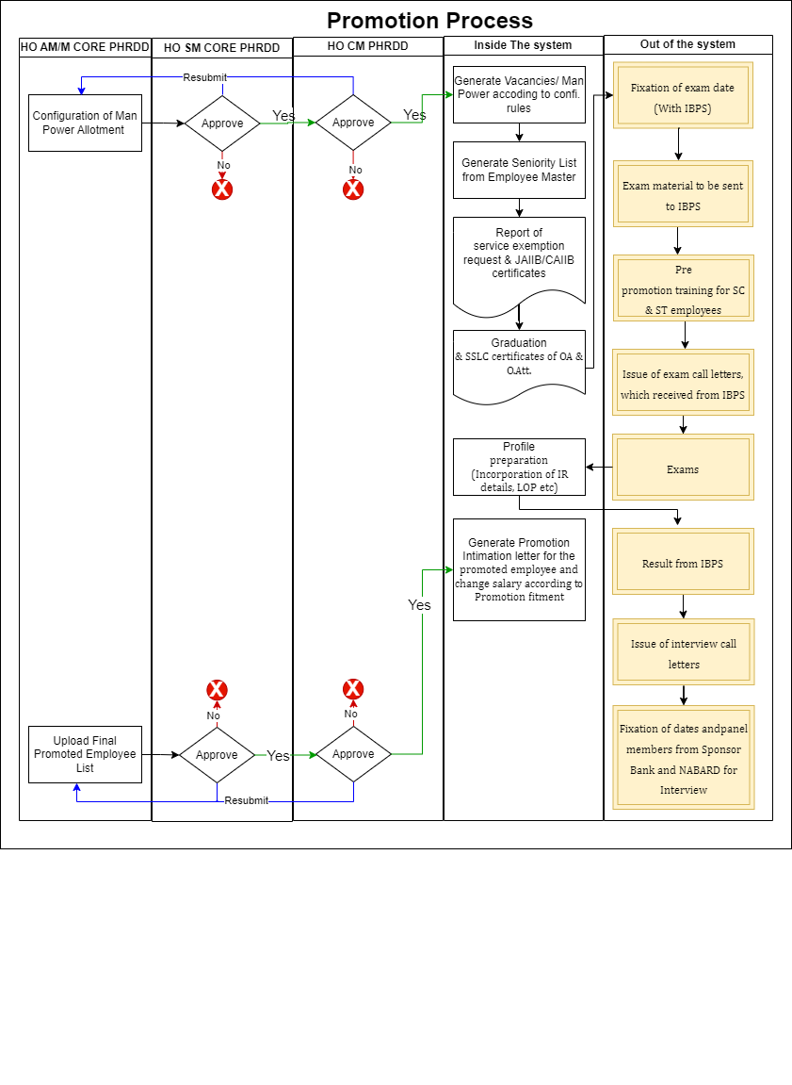

#### Use Case: Configuration of Man Power Requirement according to Mitra Commitee

**Definition:** The Mitra Committee, officially known as the "Committee on Banking Regulations and Supervisory Practices," was a committee formed by the Reserve Bank of India (RBI) to review the system of regulations and supervisory practices in the Indian banking sector. The committee was headed by M. Narasimham, who was the Chairman of the committee. The committee's report is commonly referred to as the "Mitra Committee Report." On the basis of Mitra Committee report user can allot the man power of each and every branch according to its category.

**Purpose:** The purpose of the use case is to allot the man power to each branch according to Branch Category.

**Goal of Requirement:** User should be able to allot the man power according to business Criteria and business Category.

**User: -** HO AM/ M CORE PHRDD

**Pre-conditions:**

1. User should be the permanent staff.
2. User shouldn’t be resigned, exited, suspended, retired, disable.
3. User should have rights of Man power Allotment.
4. Manpower configuration should be undertaken if there are any changes coming from Mitra Guidelines.

**Basic Flow:**

1. User logs into the HRMS solution successfully.
2. User navigates to the Transfer and Promotion from menu and upon click on man power configuration.
   1. System should open a new window with the below form.

**Form Details:**

|  |  |  |  |  |
| --- | --- | --- | --- | --- |
| **#** | **Field  Name** | **Element** | **Property** | **Remarks/Validation** |
| 1. | ASSESSMENT OF MANPOWER REQUIREMENT AS ON 31.03.<Year> (As per Mitra Committee)* | Rich Text Box | Read Only | ASSESSMENT OF MANPOWER REQUIREMENT AS ON 31.03.<Year> |
| 2. | Assessment of Manpower Requirement (As per Mitra Committee)*- Section | | | |
| 2.1 | Business Category* | Dropdown | Input | **Value:**   1. Category A1 2. Category A2 3. Category B1 4. Category B2 5. Category C1 6. Category C2 7. Category D1 8. Category D2 9. Category E1 10. Category E2 11. Chairman 12. GMs 13. CVO 14. Head Office 15. Inspectors Scale II 16. Inspectors Scale III 17. Regional Office 18. Currency Chest 19. RBTC 20. FSS 21. CCPC |
| 2.2 | Total Business (in Crore)* | Text | Read Only | System should display the Total Business according to selected Business Category from Branch category configuration database. |
| 2.3 | Advances* | Text | Read Only | System should display the Advance according to selected Business Category from Branch category configuration database. |
| 2.4 | Number of Branch* | Number | Read Only | System should display number of branches in selected Business Category from Branch category configuration database. |
| 2.5 | Number of scale 1 officer required for business category <Selected Business Category>* | Number | Input |  |
| 2.6 | Number of scale 2 officer required for business category <Selected Business Category>* | Number | Input |  |
| 2.7 | Number of scale 3 officer required for business category <Selected Business Category>* | Number | Input |  |
| 2.8 | Number of scale 4 officer required for business category <Selected Business Category>* | Number | Input |  |
| 2.9 | Number of scale 5 officer required for business category <Selected Business Category>* | Number | Input |  |
| 2.10 | Number of scale 6 officer required for business category <Selected Business Category>* | Number | Input |  |
| 2.11 | Total Officer required for business category <Selected Business Category>* | Calculator | Read Only | Total Officer required for business category <Selected Business Category>= Number of scale 1 officer required for business category <Selected Business Category>+ Number of scale 2 officer required for business category <Selected Business Category> + Number of scale 3 officer required for business category <Selected Business Category>+ Number of scale 4 officer required for business category <Selected Business Category>+ Number of scale 5 officer required for business category <Selected Business Category>+ Number of scale 6 officer required for business category <Selected Business Category> |
| 2.12 | Number of Office Assistant require for business category <Selected Business Category> * | Number | Input |  |
| 2.13 | Office Attendant Required for business category <Selected Business Category>* | Number | Input |  |
| 2.14 | Total Man power Required | Calculator | Read Only | Total Man power Required = Total Officer required for business category <Selected Business Category> + Number of Office Assistant require for business category <Selected Business Category>+ Office Attendant Required for business category <Selected Business Category> |

1. After filling the form, User will click on Submit Button.

**Note:** Field names with (*) Asterisk symbol is mandatory, rest is optional.

**Post Conditions:**

1. System should display the toaster message “Man power Configuration request submitted successfully”.
2. System should send the Man power Configuration details for Approval as per the defined workflow.
3. Upon final approval as per the workflow defined, Man power should be generated.
4. The system should maintain an audit trail of configuration changes for accountability and compliance purposes.
5. The system should maintain historical eligibility data for reporting or auditing purposes.

**Workflow:**

1. HO AM/M CORE PHRDD→ HO SM CORE PHRDD→ HO CM PHRDD

**Workflow Explanation:**

Step 1 – The HO AM/M CORE PHRDD will fill in the required details in the configuration form and submit it.

Step 2 – The HO SM CORE PHRDD will receive a task notification to review the request and approve or reject it.

* Upon Approval - It will be passed on to HO CM PHRDD for review, and further, it will be approved or rejected by HO CM PHRDD.
* Upon Rejection – The requestor will be notified of the rejection, and the task will be terminated.
* Upon Resubmit - Go back to Step 1.

Step 3 – The HO CM PHRDD will receive a task notification to review the request and approve or reject the Man power Configuration request.

* Upon Approval - The task will be completed, and HO CM PHRDD will be notified of the approval.
* Upon Rejection – The requestor will be notified of the rejection, and the task will be terminated.
* Upon Resubmit – Go back to Step 1.

**Business Rules and Validations:** NIL

**Assumptions:**

1. Only the Active and authorized user can make configuration.
2. Manpower configuration should be undertaken if there are any changes coming from Mitra Guidelines.

**Constraints:** NIL

#### Functional User stories for man power configuration

|  |  |  |  |  |
| --- | --- | --- | --- | --- |
| **Id** | **Functionality** | **Role** | **Description** | **Acceptance criteria/ Remarks** |
| MPC- 01 | MPC-Approval | HO SM CORE PHRDD | As a HO SM CORE PHRDD, I should be able to approve and reject with remarks |  |
| MPC- 02 | MPC Approval | HO CM PHRDD | As a HO CM PHRDD, I should be able to approve and reject with remarks |  |
| MPC-03 | View MPC List | HO AM/M CORE PHRDD, HO SM CORE PHRDD, HO CM PHRDD | As a user, I should be able to view all the approved/rejected/pending Man power configuration list applied. |  |

#### Use Case: Man power Allotment Report

**Definition and Purpose**: A "Manpower Allotment Report" is a document that provides detailed information about the allocation and distribution of human resources or manpower within KVGB.

**Goal of Requirement:** System should generate a man power allotment Report.

**User: -** HO AM/M CORE PHRDD, HO SM CORE PHRDD, HO CM CORE PHRDD

**Pre-conditions:**

1. User should be the permanent staff.
2. User shouldn’t be resigned, exited, suspended, retired, disable.
3. User should have rights of man power allotment report.
4. Man power allotment configuration must be approved by the final approver.

**Basic Flow:**

1. User logs into the HRMS solution successfully.
2. User navigates to the Transfer and Promotion from menu and upon click on man power Allotment Report.
   1. System should open a new window with the below fields.

**Form Details:**

|  |  |  |  |  |
| --- | --- | --- | --- | --- |
| **#** | **Field  Name** | **Element** | **Property** | **Remarks/Validation** |
| 1. | ASSESSMENT REPORT OF MANPOWER REQUIREMENT AS ON 31.03.<Year> (As per Mitra Committee)* | Rich Text Box | Read Only | ASSESSMENT REPORT OF MANPOWER REQUIREMENT |
| 2.1 | Business Category* | Text | Read Only | Data should be fetched from Configuration of branch Category. |
| 2.3 | Number Of Branch | Text | Read Only | Data should be fetched from Summary Report of branch Category. |
| 2.3 | Number of scale 1 officer required for business category <Selected Business Category> | Text | Read Only | Data should be fetched from Configuration of man Power Database. |
| 2.4 | Total officer required of Scale 1 for business category <Selected Business Category> | Calculator | Read Only | Total officer required of Scale 1 for business category <Selected Business Category>= Number of Branch *Number of scale 1 officer required for business category <Selected Business Category> |
| 2.5 | Number of scale 2 officer required for business category <Selected Business Category> | Text | * Read Only | Data should be fetched from Configuration of man Power Database. |
| 2.6 | Total officer required of Scale 2 for business category <Selected Business Category> | Calculator | Read Only | Total officer required of Scale 2 for business category <Selected Business Category>= Number of Branch *Number of scale 2 officer required for business category <Selected Business Category> |
| 2.7 | Number of scale 3 officer required for business category <Selected Business Category> | Text | Read Only | Data should be fetched from Configuration of man Power Database. |
| 2.8 | Total officer required of Scale 3 for business category <Selected Business Category> | Calculator | Read Only | Total officer required of Scale 3 for business category <Selected Business Category>= Number of Branch *Number of scale 3 officer required for business category <Selected Business Category> |
| 2.9 | Number of scale 4 officer required for business category <Selected Business Category> | Text | Read Only | Data should be fetched from Configuration of man Power Database. |
| 2.10 | Total officer required of Scale 4 for business category <Selected Business Category> | Calculator | Read Only | Total officer required of Scale 4 for business category <Selected Business Category>= Number of Branch *Number of scale 4 officer required for business category <Selected Business Category> |
| 2.11 | Number of scale 5 officer required for business category <Selected Business Category> | Text | Read Only | Data should be fetched from Configuration of man Power Database. |
| 2.12 | Total officer required of Scale 5 for business category <Selected Business Category> | Calculator | Read Only | Total officer required of Scale 5 for business category <Selected Business Category>= Number of Branch *Number of scale 5 officer required for business category <Selected Business Category> |
| 2.13 | Number of scale 6 officer required for business category <Selected Business Category> | Text | Read Only | Data should be fetched from Configuration of man Power Database. |
| 2.14 | Total officer required of Scale 6 for business category <Selected Business Category> | Calculator | Read Only | Total officer required of Scale 6 for business category <Selected Business Category>= Number of Branch *Number of scale 6 officer required for business category <Selected Business Category> |
| 2.15 | Total Officer Required for Business Category <Selected Business Category> | Calculator | Read Only | Total Officer Required for Business Category <Selected Business Category> = Total officer required of Scale 1 for business category <Selected Business Category> + Total officer required of Scale 2 for business category <Selected Business Category>+ Total officer required of Scale 3 for business category <Selected Business Category>+ Total officer required of Scale 4 for business category <Selected Business Category>+ Total officer required of Scale 5 for business category <Selected Business Category>+ Total officer required of Scale 6 for business category <Selected Business Category> |
| 2.16 | Number of Office Assistant require for business category <Selected Business Category> | Text | Read Only | Data should be fetched from Configuration of man Power Database. |
| 2.17 | Total Office Assistant required in <Selected Business Category> | Calculator | Read Only | Total Office Assistant required in Business Category = Number of Branch * Number of Office Assistant require for business category <Selected Business Category> |
| 2.19 | Office Attendant Required for business category <Selected Business Category> | Text | Read Only | Data should be fetched from Configuration of man Power Database. |
| 2.29 | Total Office Attendant Required for Business Category <Selected Business Category> | Calculator | Read Only | Total Office Attendant Required for Business Category <Selected Business Category>= Number of Branch *OFFICE ATTENDENT Required for business category <Selected Business Category> |
| 3.1 | Total Scale 1 officer required for all Business Category | Calculator | Read Only | Total Scale 1 officer required for all Business Category = Total officer required of Scale 1 for business category A + Total officer required of Scale 1 for business category B + Total officer required of Scale 1 for business category C + Total officer required of Scale 1 for business category D + Total officer required of Scale 1 for business category E |
| 3.2 | Total Scale 2 officer required for all Business Category | Calculator | Read Only | Total Scale 2 officer required for all Business Category = Total officer required of Scale 2 for business category A + Total officer required of Scale 2 for business category B + Total officer required of Scale 2 for business category C + Total officer required of Scale 2 for business category D + Total officer required of Scale 2 for business category E |
| 3.3 | Total Scale 3 officer required for all Business Category | Calculator | Read Only | Total Scale 3 officer required for all Business Category = Total officer required of Scale 3 for business category A + Total officer required of Scale 3 for business category B + Total officer required of Scale 3 for business category C + Total officer required of Scale 3 for business category D + Total officer required of Scale 3 for business category E |
| 3.4 | Total Scale 4 officer required for all Business Category | Calculator | Read Only | Total Scale 4 officer required for all Business Category = Total officer required of Scale 4 for business category A + Total officer required of Scale 4 for business category B + Total officer required of Scale 4 for business category C + Total officer required of Scale 4 for business category D + Total officer required of Scale 4 for business category E |
| 3.5 | Total Scale 5 officer required for all Business Category | Calculator | Read Only | Total Scale 5 officer required for all Business Category = Total officer required of Scale 5 for business category A + Total officer required of Scale 5 for business category B + Total officer required of Scale 5 for business category C + Total officer required of Scale 5 for business category D + Total officer required of Scale 5 for business category E |
| 3.6 | Total Scale 6 officer required for all Business Category | Calculator | Read Only | Total Scale 6 officer required for all Business Category = Total officer required of Scale 6 for business category A + Total officer required of Scale 6 for business category B + Total officer required of Scale 6 for business category C + Total officer required of Scale 6 for business category D + Total officer required of Scale 6 for business category E |
| 3.7 | Total Office Assistant Required for all business category | Calculator | Read Only | Total Office Assistant required for all Business Category = Total Office Assistant required for business category A + Total Office Assistant required for business category B+ Total Office Assistant required for business category C+ Total Office Assistant required for business category D+ Total Office Assistant required for business category E |
| 3.8 | Total OFFICE ATTENDENT required in all business Category | Calculator | Read Only | Total OFFICE ATTENDENT required for all Business Category = Total OFFICE ATTENDENT required for business category A + Total OFFICE ATTENDENT required for business category B+ Total OFFICE ATTENDENT required for business category C+ Total OFFICE ATTENDENT required for business category D+ Total OFFICE ATTENDENT required for business category E |
| 4 | Total | Calculator | Read Only | Total = Total Scale 1 officer required for all Business Category + Total Scale 2 officer required for all Business Category + Total Scale 3 officer required for all Business Category + Total Scale 4 officer required for all Business Category + Total Scale 5 officer required for all Business Category + Total Scale 6 officer required for all Business Category + Total Office Assistant required in all business Category+ Total OFFICE ATTENDENT required in all business Category |

**Note:** Field names with (*) Asterisk symbol is mandatory, rest is optional.

**Post Conditions:**

1. System should generate the Man power Allotment wise.
2. Users should be able to view and download the Branch category report.
3. Report should be download in Excel and PFD both format.

**Business Rules and Validation:**

1. System should display this report according to according branch Category.
2. Users can filter the required data by selecting the desired filter and entering a value at the top of the column.

**Example**: All the branches from category- A should be display in below format.

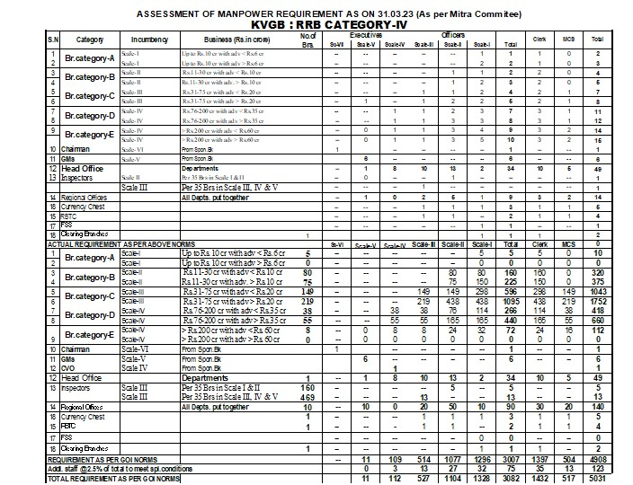

**Assumptions:**

1. Only the Active and authorized user can make view and Download report.

**Constraints:** NIL

#### Use Case: Report of Man Power Assessment

**Goal of Requirement:** System should generate a Man Power Assessment Report for KVGB.

**User: -** HO AM/M CORE PHRDD, HO SM CORE PHRDD, HO CM PHRDD

**Pre-conditions:**

1. User should be the permanent staff.
2. User shouldn’t be resigned, exited, suspended, retired, disable.
3. Man power allotment configuration should be done.

**Basic Flow:**

1. User logs into the HRMS solution successfully.0
2. User navigates to the Transfer and Promotion from menu and upon click on Man Power Assessment Report.
   1. System should open a new window with the below fields.

|  |  |  |  |  |
| --- | --- | --- | --- | --- |
| **#** | **Field  Name** | **Element** | **Property** | **Remarks/Validation** |
| 1. | Requirement of staff as per Categorisation of existing Branches as per Mitra committee Recommendations | Text | Read Only | * Requirement of staff as per Categorisation of existing Branches as per Mitra committee Recommendations. * This Data should be display in ROW Level. * This data should be fetched from Man power Assessment Report. |
| 1.1 | Scale 5 | Number | Read Only | * This data should be display at COLUMN Level. * System should fetch these value <Total Scale 5 officer required for all Business Category> from Man Power Allotment Report |
| 1.2 | Scale 4 | Number | Read Only | * System should fetch these value <Total Scale 4 officer required for all Business Category> from Man Power Allotment Report * This data should be display column Level. |
| 1.3 | Scale 3 | Number | Read Only | * System should fetch these value <Total Scale 3 officer required for all Business Category> from Man Power Allotment Report * This data should be display column Level. |
| 1.4 | Scale 2 | Number | Read Only | * System should fetch these value <Total Scale 2 officer required for all Business Category> from Man Power Allotment Report * This data should be display column Level. |
| 1.5 | Scale 1 | Number | Read Only | * System should fetch these value <Total Scale 1 officer required for all Business Category> from Man Power Allotment Report * This data should be display column Level. |
| 1.6 | Office Assistant | Number | Read Only | * System should fetch these value <Total Office Assistant required for all Business Category> from Man Power Allotment Report * This data should be display column Level. |
| 1.7 | Office Attendant | Number | Read Only | * System should fetch these value <Total Office Attendant required for all Business Category> from Man Power Allotment Report |
| 1.8 | Total | Number | Read Only | * System should fetch these value Total from Man Power Allotment Report * This data should be display column Level. |
| 2 | Add: Plan for new Branches during <Financial Year> | Text | Read Only | * Add: Plan for new Brs. during <Financial Year> * This Data should be display in ROW Level. |
| 2.1 | Scale 5 | Number | Read Only | * This Data should be appeared from Branch Master. Otherwise this should be 000. * This data should be display column Level. |
| 2.2 | Scale 4 | Number | Read Only |
| 2.3 | Scale 3 | Number | Read Only |
| 2.4 | Scale 2 | Number | Read Only |
| 2.5 | Scale 1 | Number | Read Only |
| 2.6 | Office Assistant | Number | Read Only |
| 2.7 | Office Attendant | Number | Read Only |
| 2.8 | Total | Number | Read Only | * Total = Field Number (2.8= 2.1+2.2+2.3+2.4+2.5+2.6+2.7) |
| 3 | Add: Retirement during <Financial Year> | Text | Read Only | * Add: Retirement During <Financial Year> * This Data should be display in ROW Level. |
| 3.1 | Scale 5 | Number | Read Only | * This data should be fetched from Retirement Database. * How many officers of scale 5 are going to retired in this Year. * This data should be display column Level. |
| 3.2 | Scale 4 | Number | Read Only | * This data should be fetched from Retirement Database. * How many officers of scale 4 are going to retired in this Year. * This data should be display column Level. |
| 3.3 | Scale 3 | Number | Read Only | * This data should be fetched from Retirement Database. * How many officers of scale 3 are going to retired in this Year. * This data should be display column Level. |
| 3.4 | Scale 2 | Number | Read Only | * This data should be fetched from Retirement Database. * How many officers of scale 2 are going to retired in this Year. * This data should be display column Level. |
| 3.5 | Scale 1 | Number | Read Only | * This data should be fetched from Retirement Database. * How many officers of scale 1 are going to retired in this Year. * This data should be display column Level. |
| 3.6 | Office Assistant | Number | Read Only | * This data should be fetched from Retirement Database. * How many Office Assistants are going to retired in this Year? * This data should be display column Level. |
| 3.7 | Office Attendant | Number | Read Only | * This data should be fetched from Retirement Database. * How many officers of scale OFFICE ATTENDENT are going to retired in this Year. * This data should be display column Level. |
| 3.8 | Total | Calculate | Read Only | * Total = Field Number (3.8= 3.1+3.2+3.3+3.4+3.5+3.6+3.7) * This data should be display column Level. |
| 4 | Requirement as per GOI Norms | Text | Read Only | * Requirement as per GOI Norms * This data should be display Row Level. |
| 4.1 | Scale 5 | Calculator | Read Only | * This data should be display Column Level. * 4.1= 1.1+2.1+3.1 |
| 4.2 | Scale 4 | Calculator | Read Only | * This data should be display Column Level. * 4.2= 1.2+2.2+3.2 |
| 4.3 | Scale 3 | Calculator | Read Only | * This data should be display Column Level. * 4.3= 1.3+2.3+3.3 |
| 4.4 | Scale 2 | Calculator | Read Only | * This data should be display Column Level. * 4.4= 1.4+2.4+3.4 |
| 4.5 | Scale 1 | Calculator | Read Only | * This data should be display Column Level. * 4.5= 1.5+2.5+3.5 |
| 4.6 | Office Assistant | Calculator | Read Only | * This data should be display Column Level. * 4.6= 1.6+2.6+3.6 |
| 4.7 | Office Attendant | Calculator | Read Only | * This data should be display Column Level. * 4.7= 1.7+2.7+3.7 |
| 4.8 | Total | Calculator | Read Only | * This data should be display Column Level. * 4.8= 4.1+4.2+4.3+4.4+4.5+4.6+4.7 |
| 5 | Existing Staff as at March <Finical Year > | Text | Read Only | * Existing Staff as at March <Finical Year > |
| 5.1 | Scale 5 | Number | Read Only | * This data should be fetched from Employee Master Database. * How many officers of scale 5 are existing? * This data should be display column Level. |
| 5.2 | Scale 4 | Number | Read Only | * This data should be fetched from Employee Master Database. * How many officers of scale 4 are existing? * This data should be display column Level. |
| 5.3 | Scale 3 | Number | Read Only | * This data should be fetched from Employee Master Database. * How many officers of scale 3 are existing? * This data should be display column Level. |
| 5.4 | Scale 2 | Number | Read Only | * This data should be fetched from Employee Master Database. * How many officers of scale 2 are existing? * This data should be display column Level. |
| 5.5 | Scale 1 | Number | Read Only | * This data should be fetched from Employee Master Database. * How many officers of scale 1 are existing? * This data should be display column Level. |
| 5.6 | Office Assistant | Number | Read Only | * This data should be fetched from Employee Master Database. * How many Clerical staff are existing? * This data should be display column Level. |
| 5.7 | Office Attendant | Number | Read Only | * This data should be fetched from Employee Master Database. * How many officer Office Attendant are existing? * This data should be display column Level. |
| 5.8 | Total | Calculator | Read Only | * This data should be display column Level. * 5.8 = 5.1+5.2+5.3+5.4+5.5+5.6+5.7 |
| 6 | Net staff required | Text | Read Only | Net staff required |
| 6.1 | Scale 5 | Calculator | Read Only | * 6.1=4.1-5.1 |
| 6.2 | Scale 4 | Calculator | Read Only | * 6.2=4.2-5.2 |
| 6.3 | Scale 3 | Calculator | Read Only | * 6.3=4.3-5.3 |
| 6.4 | Scale 2 | Calculator | Read Only | * 6.4=4.4-5.4 |
| 6.5 | Scale 1 | Calculator | Read Only | * 6.5=4.5-5.5 |
| 6.6 | Office Assistant | Calculator | Read Only | * 6.6=4.6-5.6 |
| 6.7 | Office Attendant | Calculator | Read Only | * 6.7=4.7-5.7 |
| 6.8 | Total | Calculator | Read Only | * This data should be display column Level. * 6.8 = 6.1+6.2+6.3+6.4+6.5+6.6+6.7 |
| 7 | Officers joined after starting of <Financial Year>, if any | Text | Read Only | Officers joined after<Financial Year>, if any |
| 7.1 | Scale 5 | Number | Read Only | * This data should be fetched from Employee Master Database. * How many officers of scale 5 are joined after starting of Financial Year. * This data should be display column Level. |
| 7.2 | Scale 4 | Number | Read Only | * This data should be fetched from Employee Master Database. * How many officers of scale 4 are joined after starting of Financial Year. * This data should be display column Level. |
| 7.3 | Scale 3 | Number | Read Only | * This data should be fetched from Employee Master Database. * How many officers of scale 3 are joined after starting of Financial Year. * This data should be display column Level. |
| 7.4 | Scale 2 | Number | Read Only | * This data should be fetched from Employee Master Database. * How many officers of scale 2 are joined after starting of Financial Year. * This data should be display column Level. |
| 7.5 | Scale 1 | Number | Read Only | * This data should be fetched from Employee Master Database. * How many officers of scale 1 are joined after starting of Financial Year. * This data should be display column Level. |
| 7.6 | Office Assistant | Number | Read Only | * This data should be fetched from Employee Master Database. * How many Office Assistants are joined after starting of Financial Year. * This data should be display column Level. |
| 7.7 | Office Attendant | Number | Read Only | * This data should be fetched from Employee Master Database. * How many are Office Attendant joined after starting of Financial Year. * This data should be display column Level. |
| 7.8 | Total | Calculate | Read Only |  |
| 8 | Total requirement after newly joined staff | Text | Read Only | Total requirement after newly joined staff |
| 8.1 | Scale 5 | Calculator | Read Only | * 8.1= 6.1-7.1 |
| 8.2 | Scale 4 | Calculator | Read Only | * 8.2= 6.2-7.1 |
| 8.3 | Scale 3 | Calculator | Read Only | * 8.3= 6.3-7.1 |
| 8.4 | Scale 2 | Calculator | Read Only | * 8.4= 6.4-7.1 |
| 8.5 | Scale 1 | Calculator | Read Only | * 8.5= 6.5-7.1 |
| 8.6 | Office Assistant | Calculator | Read Only | * 8.6= 6.6-7.1 |
| 8.7 | Office Attendant | Calculator | Read Only | * 8.7= 6.7-7.1 |
| 8.8 | Total | Calculator | Read Only | * 8.8 = 8.1+8.2+8.3+8.4+8.5+8.6+8.7 |
| 9 | Vacancies raised on account of Internal promotion | Text | Read Only | Vacancies raised on account of Internal promotion |
| 9.1 | Scale 5 | Number | Read Only | This data should be fetched from last year promotion data “How many promotions were done last year for Scale 5” |
| 9.2 | Scale 4 | Number | Read Only | This data should be fetched from last year promotion data “How many promotions were done last year for Scale 4” |
| 9.3 | Scale 3 | Number | Read Only | This data should be fetched from last year promotion data “How many promotions were done last year for Scale 3” |
| 9.4 | Scale 2 | Number | Read Only | This data should be fetched from last year promotion data “How many promotions were done last year for Scale 2” |
| 9.5 | Scale 1 | Number | Read Only | This data should be fetched from last year promotion data “How many promotions were done last year for Scale 1” |
| 9.6 | Office Assistant | Number | Read Only | This data should be fetched from last year promotion data “How many promotions were done last year for Office Assistant” |
| 9.7 | Office Attendant | Number | Read Only | 0 |
| 9.8 | Total | Calculator | Read Only | 9.8 = 9.1+9.2+9.3+9.4+9.5+9.6+9.7 |
| 10 | Total staff required in each cadre after considering the vacancies arose on account of internal promotion | Text | Read Only | Total staff required in each cadre after considering the vacancies arose on account of internal promotion |
| 10.1 | Scale 5 | Calculator | Read Only | 10.1= 8.1+9.1 |
| 10.2 | Scale 4 | Calculator | Read Only | 10.2= 8.2+9.2 |
| 10.3 | Scale 3 | Calculator | Read Only | 10.3= 8.3+9.3 |
| 10.4 | Scale 2 | Calculator | Read Only | 10.4= 8.4+9.4 |
| 10.5 | Scale 1 | Calculator | Read Only | 10.5= 8.5+9.5 |
| 10.6 | Office Assistant | Calculator | Read Only | 10.6= 8.6+9.6 |
| 10.7 | Office Attendant | Calculator | Read Only | 10.7= 8.7+9.7 |
| 10.8 | Total | Calculator | Read Only | 10.8 = 10.1 + 10.2+10.3+10.4+10.5+10.6+10.7 |
| 11 | Ratio of Promotion to Direct Recruitment | Text | Read Only | Ratio of Promotion to Direct Recruitment |
| 11.1 | Scale 5 | Text | Read Only | 100:00 |
| 11.2 | Scale 4 | Text | Read Only | 100:00 |
| 11.3 | Scale 3 | Text | Read Only | 90:10 |
| 11.4 | Scale 2 | Text | Read Only | 75:25 |
| 11.5 | Scale 1 | Text | Read Only | 50:50 |
| 11.6 | Office Assistant | Text | Read Only | 25:75 |
| 11.7 | Office Attendant | Text | Read Only | 00:100 |
| 12 | Ratio of Normal track to Fast track Promotion | Text | Read Only | Ratio of Normal track to Fast track Promotion |
| 12.1 | Scale 5 | Text | Read Only | 100:00 |
| 12.2 | Scale 4 | Text | Read Only | 100:00 |
| 12.3 | Scale 3 | Text | Read Only | 50:50 |
| 12.4 | Scale 2 | Text | Read Only | 50:50 |
| 12.5 | Scale 1 | Text | Read Only | 50:50 |
| 12.6 | Office Assistant | Text | Read Only | 70:30 |
| 12.7 | Office Attendant | Text | Read Only | NA |
| 13 | Vacancies for PROMOTION | Text | Read Only | Vacancies for PROMOTION |
| 13.1 | Scale 5 | Calculator | Read Only | 13.1 = (10.1/100) * 100 (Promotion ratio of scale 5) |
| 13.2 | Scale 4 | Calculator | Read Only | 13.2 = (10.2/100)*100 (Promotion ratio of scale 4) |
| 13.3 | Scale 3 | Calculator | Read Only | 13.3=(10.3/100)*90 (Promotion ratio of scale 3)  System should take round down value. |
| 13.4 | Scale 2 | Calculator | Read Only | 13.4=(10.4/100)*75 (Promotion ratio of scale 2)  System should take round down value. |
| 13.5 | Scale 1 | Calculator | Read Only | 13.5=(10.5/100)*50 (Promotion ratio of scale 1)  System should take round down value. |
| 13.6 | Office Assistant | Calculator | Read Only | 13.6=(10.6/100)*25 (Promotion ratio of Office Assistant)  System should take round down value. |
| 13.7 | Office Attendant | Calculator | Read Only | 13.7=(10.7/100)*00 (Promotion ratio of scale MIS)  System should take round down value. |
| 13.8 | Total | Calculator | Read Only | 13.8 = 13.1+13.2+13.3+13.4+13.5+13.6+13.7 |
| 14 | Vacancies for Direct Recruitment | Text | Read Only | Vacancies for Direct Recruitment |
| 14.1 | Scale 5 | Calculator | Read Only | 14.1=(10.1/100)*00 (Direct recruitment ratio of scale 5)  System should take round up value. |
| 14.2 | Scale 4 | Calculator | Read Only | 14.2=(10.2/100)*00 (Direct recruitment ratio of scale 4)  System should take round up value. |
| 14.3 | Scale 3 | Calculator | Read Only | 14.3=(10.3/100)* 10 (Direct recruitment ratio of scale 3)  System should take round up value. |
| 14.4 | Scale 2 | Calculator | Read Only | 14.4= (10.4/100)*25 (Direct recruitment ratio of scale 2)  System should take round up value. |
| 14.5 | Scale 1 | Calculator | Read Only | 14.5=(10.5/100)*50 (Direct recruitment ratio of scale 1)  System should take round up value. |
| 14.6 | Office Assistant | Calculator | Read Only | 14.6 = (10.6/100)*75 (Promotion ratio of office Attendant)  System should take round up value. |
| 14.7 | Office Attendant | Calculator | Read Only | 14.7=(10.7/100)* 00 (Promotion ratio of office Attendant) |
| 14.8 | Total | Calculator | Read Only | 14.8 = 14.1+14.2+14.3+14.4 +14.5 +14.6 +14.7 |
| 15 | Normal Channel | Text | Read Only | Normal Channel |
| 15.1 | Scale 5 | Calculator | Read Only | 15.1 = (13.1/100)*100 (Normal Channel ratio of scale 5)  System should take round down value. |
| 15.2 | Scale 4 | Calculator | Read Only | 15.2 = (13.2/100)*100 (Normal ratio of scale 4)  System should take round down value. |
| 15.3 | Scale 3 | Calculator | Read Only | 15.3=(13.3/100)*50 (Normal ratio of scale 3)  System should take round down value. |
| 15.4 | Scale 2 | Calculator | Read Only | 15.4=(13.4/100)*50 (Normal ratio of scale 2)  System should take round down value. |
| 15.5 | Scale 1 | Calculator | Read Only | 15.5=(13.5/100)*50 (Normal ratio of scale 1)  System should take round down value. |
| 15.6 | Office Assistant | Calculator | Read Only | 15.6=(13.6/100)*70 (Normal ratio of office Assistant)  System should take round down value. |
| 15.7 | Office Attendant | Calculator | Read Only | NA |
| 15.8 | Total | Calculator | Read Only | 15.8 =15.1 + 15.2 +15.3+15.4+15.5+15.6+15.7 |
| 16 | Fast Track | Text | Read Only | Fast Track |
| 16.1 | Scale 5 | Calculator | Read Only | 16.1 = (13.1/100)*00 (Fast track ratio of scale 5)  System should take round down value. |
| 16.2 | Scale 4 | Calculator | Read Only | 16.2 = (13.2/100)*00 (Fast track ratio of scale 4)  System should take round down value. |
| 16.3 | Scale 3 | Calculator | Read Only | 16.3=(13.3/100)*50 (Fast track ratio of scale 3)  System should take round down value. |
| 16.4 | Scale 2 | Calculator | Read Only | 16.4=(13.4/100)*50 (Fast track ratio of scale 2)  System should take round down value. |
| 16.5 | Scale 1 | Calculator | Read Only | 16.5=(13.5/100)*50 (Fast track ratio of scale 1)  System should take round down value. |
| 16.6 | Office Assistant | Calculator | Read Only | 16.6=(13.6/100)*30 (Fast track ratio of office Assistant)  System should take round down value. |
| 16.7 | Office Attendant | Calculator | Read Only | NA |
| 16.8 | Total | Calculator | Read Only | 16.8= 16.1+ 16.2 +16.3+16.4+16.5+16.6+16.7 |

**Post Conditions:**

1. System should generate the Man Power assessment report.
2. Users should be able to view and download the man power assessment report.
3. Report should be download in Excel and PFD both format.

**Business Rules and Validation:**

1. Users can filter the required data by selecting the desired filter and entering a value at the top of the column.
2. System should display report in the given format.

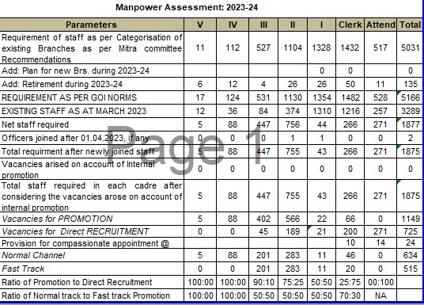

**Assumptions:**

1. Only the Active and authorized user can view and download report.

**Constraints:** NIL

#### Use Case: Seniority List Report

**Goal of Requirement:** System should generate a Seniority List Report.

**User: -** HO AM/M CORE PHRDD, HO SM CORE PHRDD, HO CM PHRDD

**Pre-conditions:**

1. User should be the permanent staff.
2. User shouldn’t be resigned, exited, suspended, retired, disable.

**Basic Flow:**

1. User logs into the HRMS solution successfully.
2. User navigates to the Transfer and Promotion from menu and upon click on Seniority List Report.
3. System should open a new window with the below fields.

|  |  |  |  |  |
| --- | --- | --- | --- | --- |
| **#** | **Field  Name** | **Element** | **Property** | **Remarks/Validation** |
| 1. | Annexure-<Count>  Seniority List of Officers (Scale-No) as on<Financial Year > | Rich Text Box | Read Only | **Annexure-<Count>**  **Seniority List of Officers, Office Assistant, office Attendant <Scale-No> as on < Financial Year >**  Example: Annexure-I  Seniority List of Officers (Scale-III) as on 01.04.2023 |
| 1.1 | Sr. No | - | - |  |
| 1.2 | EPF No. | Text | Read Only | * The system is required to retrieve the specified details from the employee master. * Users should have the capability to select the Date of Joining to the cadre. * Upon selecting the date, the system should display the relevant data associated with that date. |
| 1.3 | Employee Name | Text | Read Only |
| 1.4 | Date of Birth | Date | Read Only |
| 1.5 | Date of joining to Cadre | Date | Read Only |

**Post Conditions:**

1. System should generate the Seniority List report.
2. Users should be able to view and download the Seniority List report.
3. Report should be download in Excel and PFD both format.

**Business Rules and Validation:**

1. System should display all employee data in Seniority List.
2. Report data should be displayed in ascending order of the date of joining to cadre.

* System should display that employee data who joined this cadre first.
* For Example: - if an employee join scale 3 in 01-04-2022 and other employee join 01-04-2023, then system should display first who joined first.

1. The system will not display members who have resigned, exited, retired, or are disabled in the Employee Master database in this seniority list.
2. This list should be reflect separately for every scale.
3. Users can filter the required data by selecting the desired filter and entering a value at the top of the column.
4. Seniority data should be displayed separately according to the scale.

* For example, all Scale 3 senior officers should be listed in Seniority List of Officers (Scale-III)
* For example, all Scale 4 senior officers should be listed in Seniority List of Officers (Scale-IV)

1. System should display report in the below format.

|  |  |  |  |  |  |  |  |  |  |  |  |  |  |  |  |  |  |  |  |  |  |  |  |  |  |  |  |  |  |  |  |  |  |  |  |  |  |  |  |  |  |  |  |  |  |  |  |  |  |  |  |  |  |  |  |  |  |  |  |  |
| --- | --- | --- | --- | --- | --- | --- | --- | --- | --- | --- | --- | --- | --- | --- | --- | --- | --- | --- | --- | --- | --- | --- | --- | --- | --- | --- | --- | --- | --- | --- | --- | --- | --- | --- | --- | --- | --- | --- | --- | --- | --- | --- | --- | --- | --- | --- | --- | --- | --- | --- | --- | --- | --- | --- | --- | --- | --- | --- | --- | --- |
| **Annexure-I**  **Seniority List of Officers (Scale-III) as on 01.04.2023**   | **Sl.No.** | **Name of Staff** | **EPF. No.** | **Date of Birth** | **Date of joining to Cadre** | | --- | --- | --- | --- | --- | | 1 | Dineshkumar H.R. | 2693 | 31.03.1964 | 24.12.2018 | | 2 | Narahari Naik K | 3104 | 18.06.1982 | 24.12.2018 | | 3 | Ashok S Sangati | 2758 | 22.07.1981 | 24.12.2018 | | 4 | Mahantesh Veeranna Karikatti | 3884 | 18.08.1989 | 24.12.2018 | | 5 | Dilipkumar Laxmanrao Madem | 3892 | 02.05.1988 | 24.12.2018 | | 6 | J.B. Kulkarni | 1706 | 18.06.1964 | 26.12.2018 | | 7 | S.A. Mhaisalkar | 1499 | 22.07.1965 | 26.12.2018 | | 8 | Sateesha Pai B | 1671 | 21.07.1965 | 22.11.2019 | | 9 | Pratibha A V | 3100 | 30.07.1986 | 22.11.2019 | | 10 | P.G. Hemadri | 1511 | 13.11.1965 | 22.11.2019 | | 11 | Mahalingappa P Bolajadar | 2770 | 15.06.1981 | 22.11.2019 | |

**Assumptions:**

1. Only the Active and authorized user can view and download report.

**Constraints:** NIL

#### Use Case: List of employee who is eligible for promotion Report

**Definition: -** A "List of Employees Eligible for Promotion Report" is a document that provides a comprehensive list of individuals within KVGB who meet the criteria for consideration for a promotion.

**Purpose:** The "List of Employees Eligible for Promotion Report" serves several important purposes within KVGB. The main purpose is Facilitates Informed Decision-Making, Promotes Transparency, and Streamlines Communication.

**Normal Channel:** "Normal Channel" typically refers to the standard or regular pathway through which employee’s progress in their careers within KVGB. It outlines the typical stages or steps that an employee follows when advancing from one position to another within the organizational hierarchy. Normal Channel for banking promotions often involves a structured and hierarchical career progression, with employees moving from entry-level positions to more senior roles.

**Fast Track Channel:** The term "Fast Track Channel" in banking promotion refers to an accelerated or expedited pathway for career advancement within the banking sector. Unlike the traditional or "Normal Channel" that follows a standard hierarchy with predefined stages of progression, the Fast Track Channel allows exceptional and high-performing individuals to move more rapidly through the ranks.

**Zone of Consideration**: Zone of Consideration refers to a predetermined range of eligible candidates who are considered for a promotion opportunity within the KVGB. The zone is typically defined based on certain criteria such as experience, performance, qualifications, and other relevant factors. This concept is often utilized in the promotion process to ensure fairness, transparency, and consistency.

**Goal of Requirement:** System should generate a List of employee who is eligible for promotion according to business rules.

**User: -** HO AM/M CORE PHRDD, HO SM CORE PHRDD, HO CM PHRDD

**Pre-conditions:**

1. User should be the permanent staff.
2. User shouldn’t be resigned, exited, suspended, retired, disable.
3. The seniority list report should be generated in the system.

**Basic Flow:**

1. User logs into the HRMS solution successfully.
2. User navigates to the Transfer and Promotion from menu and upon click on employee eligibility Report.
   1. System should open a new window with the below fields.

|  |  |  |  |  |
| --- | --- | --- | --- | --- |
| **#** | **Field  Name** | **Element** | **Property** | **Remarks/Validation** |
| 1. | List of Employee who are eligible for Promotion | Rich Text Box | Read Only | List of Employee who are eligible for Promotion |
| 2 | Sr. No | Text | Read Only |  |
| 3 | EPF No. | Text | Read Only | System should fetched these details from Employee Master. |
| 4 | Employee Name | Text | Read Only |
| 5 | Branch | Text | Read Only |
| 6 | Region / Zone | Text | Read Only |
| 7 | Present Scale | Text | Read Only |
| 8 | Category | Text | Read Only | System should fetched these details from Employee Master. |
| 9 | PH Category (HI/OC/VI) | Text | Read Only |
| 10 | Channel | Text | Read Only | The channel should be displayed based on the following business rules. |

**Post Conditions:**

1. System should generate the list of Employee who is eligible for promotion.
2. Users should be able to view and download the list of Employee who is eligible for promotion report.
3. Report should be download in Excel and PFD both format.

**Business Rules and Validation:**

1. Users can filter the required data by selecting the desired filter and entering a value at the top of the column.
2. The system should determine the channel using the following business rules.
3. **From Scale 4 to Scale 5**
4. The system should display a list of employee names for those officers who are eligible, specifically for those holding the position of Officer Senior Management (Scale IV) on a full-time and regular basis, with a minimum of 3 years of experience in the said post.
5. The minimum eligibility in terms of the number of years of service for promotion shall be reckoned as on the starting of Financial Year.
6. **From Scale 3 to Scale 4**
7. The system should display a list of employee names for those officers who are eligible, specifically for those holding the position of Officer Middle Management (Scale III) on a full-time and regular basis, with a minimum of 4 years of experience in the said post.
8. The minimum eligibility in terms of the number of years of service for promotion shall be reckoned as on the starting of Financial Year.
9. **From Scale 2 to Scale 3**

* **Normal Channel**

1. The system should display a list of employee names for those officers who are eligible, specifically for those holding the position of Officer Middle Management (Scale-II) on a full-time and regular basis, with a minimum of 7 years of experience in the said post.

**Relaxation in eligibility criteria:**

* 1. If a candidate has successfully completed the Junior Associate of the Indian Institute of Bankers (JAIIB) program from the Indian Institute of Banking and Finance, they will be granted a one-year service relaxation in the eligibility criteria.

**Example**: For instance, consider a candidate currently holding the position of Officer Middle Management (Scale-II) on a full-time and regular basis, with a minimum of 6 years of experience in the said post. If this candidate has passed the JAIIB before end of the year (31st March) has submitted the certificate on HRMS, they are now eligible for promotion through the Normal Channel.

* 1. If a candidate has successfully completed the Certified Associate of the Indian Institute of Bankers (CAIIB) program from the Indian Institute of Banking and Finance, they will be granted a one-year service relaxation in the eligibility criteria.

**Example**: For instance, consider a candidate currently holding the position of Officer Middle Management (Scale-II) on a full-time and regular basis, with a minimum of 6 years of experience in the said post. If this candidate has passed the CAIIB before end of the year (31st March) has submitted the certificate on HRMS, they are now eligible for promotion through the Normal Channel.

* 1. If a candidate has successfully completed the Junior Associate of the Indian Institute of Bankers (JAIIB) and Certified Associate of the Indian Institute of Bankers (CAIIB) program from the Indian Institute of Banking and Finance, they will be granted a Two-year service relaxation in the eligibility criteria.

**Example**: For instance, consider a candidate currently holding the position of Officer Middle Management (Scale-II) on a full-time and regular basis, with a minimum of 5 years of experience in the said post. If this candidate has passed the JAIIB and CAIIB before end of the year (31st March) has submitted the certificate on HRMS, they are now eligible for promotion through the Normal Channel.

1. Officer must have been confirmed in the feeder grade, the meaning of Feeder Grade is officer should be in cadre.
2. The minimum eligibility in terms of the number of years of service for promotion shall be reckoned as on the starting of Financial Year.
3. Zone of consideration:
4. The system should contain three times more candidates than the number of vacancies.

**Example**: if there is 5 vacancies for Normal channel then system should contain 15 candidates.

1. Vacancies under Normal Channel shall be filled after filling the vacancies under Fast Track Channel.
2. The Officers who are eligible under Normal Channel shall also be considered under Fast Track Channel.

* **Fast Track Channel**

1. The system should display a list of employee names for those officers who are eligible, specifically for those holding the position of Officer Middle Management (Scale-II) on a full-time and regular basis, with a minimum of 5 years of experience in the said post.

**Relaxation in eligibility criteria:**

1. If a candidate has successfully completed the Junior Associate of the Indian Institute of Bankers (JAIIB) program from the Indian Institute of Banking and Finance, they will be granted a one-year service relaxation in the eligibility criteria.

**Example**: For instance, consider a candidate currently holding the position of Officer Middle Management (Scale-II) on a full-time and regular basis, with a minimum of 4 years of experience in the said post. If this candidate has passed the JAIIB before end of the year (31st March) has submitted the certificate on HRMS, they are now eligible for promotion through the Fast Track Channel.

1. If a candidate has successfully completed the Certified Associate of the Indian Institute of Bankers (CAIIB) program from the Indian Institute of Banking and Finance, they will be granted a one-year service relaxation in the eligibility criteria.

**Example**: For instance, consider a candidate currently holding the position of Officer Middle Management (Scale-II) on a full-time and regular basis, with a minimum of 4 years of experience in the said post. If this candidate has passed the CAIIB before end of the year (31st March) has submitted the certificate on HRMS, they are now eligible for promotion through the Fast Track Channel.

1. If a candidate has successfully completed the Junior Associate of the Indian Institute of Bankers (JAIIB) and Certified Associate of the Indian Institute of Bankers (CAIIB) program from the Indian Institute of Banking and Finance, they will be granted a Two-year service relaxation in the eligibility criteria.

**Example**: For instance, consider a candidate currently holding the position of Officer Middle Management (Scale-II) on a full-time and regular basis, with a minimum of 3 years of experience in the said post. If this candidate has passed the JAIIB and CAIIB before end of the year (31st March) has submitted the certificate on HRMS, they are now eligible for promotion through the Fast track Channel.

1. Officer must have been confirmed in the feeder grade, the meaning of Feeder Grade is officer should be in cadre.
2. The minimum eligibility in terms of the number of years of service for promotion shall be reckoned as on the starting of Financial Year.
3. Zone of consideration: The system should consider all eligible officers in Fast Track Channel.
4. **From Scale 1 to Scale 2**

* **Normal Channel**

1. The system should display a list of employee names for those officers who are eligible, specifically for those holding the position of Officer Junior Management (Scale-I) on a full-time and regular basis, with a minimum of 8 years of experience in the said post.

**Relaxation in eligibility criteria:**

1. If a candidate has successfully completed the Junior Associate of the Indian Institute of Bankers (JAIIB) program from the Indian Institute of Banking and Finance, they will be granted a one-year service relaxation in the eligibility criteria.

**Example**: For instance, consider a candidate currently holding the position of Officer Junior Management (Scale-I) on a full-time and regular basis, with a minimum of 7 years of experience in the said post. If this candidate has passed the JAIIB before end of the year (31st March) has submitted the certificate on HRMS, they are now eligible for promotion through the Normal Channel.

1. If a candidate has successfully completed the Certified Associate of the Indian Institute of Bankers (CAIIB) program from the Indian Institute of Banking and Finance, they will be granted a one-year service relaxation in the eligibility criteria.

**Example**: For instance, consider a candidate currently holding the position of Officer Junior Management (Scale-I) on a full-time and regular basis, with a minimum of 7 years of experience in the said post. If this candidate has passed the CAIIB before end of the year (31st March) has submitted the certificate on HRMS, they are now eligible for promotion through the Normal Channel.

1. If a candidate has successfully completed the Junior Associate of the Indian Institute of Bankers (JAIIB) and Certified Associate of the Indian Institute of Bankers (CAIIB) program from the Indian Institute of Banking and Finance, they will be granted a Two-year service relaxation in the eligibility criteria.

**Example**: For instance, consider a candidate currently holding the position of Officer Junior Management (Scale-I) on a full-time and regular basis, with a minimum of 6 years of experience in the said post. If this candidate has passed the JAIIB and CAIIB before end of the year (31st March) has submitted the certificate on HRMS, they are now eligible for promotion through the Normal Channel.

1. Officer must have been confirmed in the feeder grade, the meaning of Feeder Grade is officer should be in cadre.
2. The minimum eligibility in terms of the number of years of service for promotion shall be reckoned as on the starting of Financial Year.Top of Form
3. Zone of consideration
4. The system should contain three times more Candidate than the number of vacancies.

**Example**: if there is 5 vacancies for Normal channel then system should contain 15 Candidate. The ratio of zone of consideration should be 1:3.

1. Vacancies under Normal Channel shall be filled after filling the vacancies under Fast Track Channel.
2. The Officers who are eligible under Normal Channel shall also be considered under Fast Track Channel.

* **Fast Track Channel**

1. The system should display a list of employee names for those officers who are eligible, specifically for those holding the position of Officer Middle Management (Scale-I) on a full-time and regular basis, with a minimum of 6 years of experience in the said post.

**Relaxation in eligibility criteria:**

1. If a candidate has successfully completed the Junior Associate of the Indian Institute of Bankers (JAIIB) program from the Indian Institute of Banking and Finance, they will be granted a one-year service relaxation in the eligibility criteria.

**Example**: For instance, consider a candidate currently holding the position of Officer Junior Management (Scale-I) on a full-time and regular basis, with a minimum of 5 years of experience in the said post. If this candidate has passed the JAIIB before end of the year (31st March) has submitted the certificate on HRMS, they are now eligible for promotion through the Fast Track Channel.

1. If a candidate has successfully completed the Certified Associate of the Indian Institute of Bankers (CAIIB) program from the Indian Institute of Banking and Finance, they will be granted a one-year service relaxation in the eligibility criteria.

**Example**: For instance, consider a candidate currently holding the position of Officer Junior Management (Scale-I) on a full-time and regular basis, with a minimum of 5 years of experience in the said post. If this candidate has passed the CAIIB before end of the year (31st March) has submitted the certificate on HRMS, they are now eligible for promotion through the Fast Track Channel.

1. If a candidate has successfully completed the Junior Associate of the Indian Institute of Bankers (JAIIB) and Certified Associate of the Indian Institute of Bankers (CAIIB) program from the Indian Institute of Banking and Finance, they will be granted a Two-year service relaxation in the eligibility criteria.

**Example**: For instance, consider a candidate currently holding the position of Officer Junior Management (Scale-I) on a full-time and regular basis, with a minimum of 4 years of experience in the said post. If this candidate has passed the JAIIB and CAIIB before end of the year (31st March) and has submitted the certificate on HRMS, they are now eligible for promotion through the Fast track Channel.

1. Officer must have been confirmed in the feeder grade, the meaning of Feeder Grade is officer should be in cadre.
2. The minimum eligibility in terms of the number of years of service for promotion shall be reckoned as on the starting of Financial Year.
3. Zone of consideration: The system should consider all eligible officers in Fast Track Channel.
4. **From OFFICE ASSISTANT (M) to Scale 1**

* **Normal Channel**

1. The system should display a list of employee names for those officers who are eligible, specifically for those holding the position of Office Assistant on a full-time and regular basis, with a minimum of 10 years of experience in the said post.

**Relaxation in eligibility criteria:**

1. If a candidate has successfully completed the Junior Associate of the Indian Institute of Bankers (JAIIB) program from the Indian Institute of Banking and Finance, they will be granted a one-year service relaxation in the eligibility criteria.

**Example**: For instance, consider a candidate currently holding the position of Office Assessment on a full-time and regular basis, with a minimum of 9 years of experience in the said post. If this candidate has passed the JAIIB before end of the year (31st March) and has submitted the certificate on HRMS, they are now eligible for promotion through the Normal Channel.

1. If a candidate has successfully completed the Certified Associate of the Indian Institute of Bankers (CAIIB) program from the Indian Institute of Banking and Finance, they will be granted a one-year service relaxation in the eligibility criteria.

**Example**: For instance, consider a candidate currently holding the position of Office Assistant on a full-time and regular basis, with a minimum of 9 years of experience in the said post. If this candidate has passed the CAIIB before end of the year (31st March) and has submitted the certificate on HRMS, they are now eligible for promotion through the Normal Channel.

1. If a candidate has successfully completed the Junior Associate of the Indian Institute of Bankers (JAIIB) and Certified Associate of the Indian Institute of Bankers (CAIIB) program from the Indian Institute of Banking and Finance, they will be granted a Two-year service relaxation in the eligibility criteria.

**Example**: For instance, consider a candidate currently holding the position of Office Assistant on a full-time and regular basis, with a minimum of 8 years of experience in the said post. If this candidate has passed the JAIIB and CAIIB before end of the year (31st March) and has submitted the certificate on HRMS, they are now eligible for promotion through the Normal Channel.

1. The minimum eligibility in terms of the number of years of service for promotion shall be reckoned as on the starting of Financial Year.
2. Zone of consideration
3. The system should contain three times more candidate than the number of vacancies.

**Example**: if there is 5 vacancies for Normal channel then system should contain 15 candidate.

1. Vacancies under Normal Channel shall be filled after filling the vacancies under Fast Track Channel.
2. The candidate who are eligible under Normal Channel shall also be considered under Fast Track Channel.

* **Fast Track Channel**

1. The candidate must possess Bachelor’s Degrees from a recognized University.
2. The system should display a list of employee names for those officers who are eligible, specifically for those holding the position of Office Assistant on a full-time and regular basis, with a minimum of 6 years of experience in the said post.

**Relaxation in eligibility criteria:**

1. If a candidate has successfully completed the Junior Associate of the Indian Institute of Bankers (JAIIB) program from the Indian Institute of Banking and Finance, they will be granted a one-year service relaxation in the eligibility criteria.

**Example**: For instance, consider a candidate currently holding the position of Office Assistant on a full-time and regular basis, with a minimum of 5 years of experience in the said post. If this candidate has passed the JAIIB before end of the year (31st March) and has submitted the certificate on HRMS, they are now eligible for promotion through the Fast Track Channel.

1. If a candidate has successfully completed the Certified Associate of the Indian Institute of Bankers (CAIIB) program from the Indian Institute of Banking and Finance, they will be granted a one-year service relaxation in the eligibility criteria.

**Example**: For instance, consider a candidate currently holding the position of Office Assistant on a full-time and regular basis, with a minimum of 5 years of experience in the said post. If this candidate has passed the CAIIB before end of the year (31st March) and has submitted the certificate on HRMS, they are now eligible for promotion through the Fast Track Channel.

1. If a candidate has successfully completed the Junior Associate of the Indian Institute of Bankers (JAIIB) and Certified Associate of the Indian Institute of Bankers (CAIIB) program from the Indian Institute of Banking and Finance, they will be granted a Two-year service relaxation in the eligibility criteria.

**Example**: For instance, consider a candidate currently holding the position of Office Assistant on a full-time and regular basis, with a minimum of 4 years of experience in the said post. If this candidate has passed the JAIIB and CAIIB before end of the year (31st March) and has submitted the certificate on HRMS, they are now eligible for promotion through the Fast track Channel.

1. Officer must have been confirmed in the feeder grade, the meaning of Feeder Grade is officer should be in cadre.
2. The minimum eligibility in terms of the number of years of service for promotion shall be reckoned as on the starting of Financial Year.
3. Zone of consideration: The system should consider all eligible officer Assistant in Fast Track Channel.
4. **From OFFICE ATTENDENT (M) to OFFICE ASSISTANT (M)**

* **Normal Channel**

1. The system should display a list of employee names for those officers who are eligible, specifically for those holding the position of Office Attendant on a full-time and regular basis, with a minimum of 10 years of experience in the said post.
2. Candidate must have passed 10th Standard.
3. Candidate must have been confirmed (Probationary confirmation) in the feeder grade.
4. Zone of consideration:
5. The system should contain three times more candidate than the number of vacancies.

**Example**: if there is 5 vacancies for Normal channel then system should contain 15 candidate.

1. Vacancies under Normal Channel shall be filled after filling the vacancies under Fast Track Channel.
2. Candidate who are eligible under Normal Channel shall also be considered under Fast Track Channel.
3. The minimum eligibility in terms of the number of years of service for promotion shall be reckoned as on the starting of Financial Year.

* **Fast Track Channel**

1. The system should display a list of employee names for those officers who are eligible, specifically for those holding the position of Office Attendant on a full-time and regular basis, with a minimum of 5 years of experience in the said post.
2. The candidate must possess Bachelor’s Degrees from a recognized University.
3. Candidate must have been confirmed in the feeder grade.
4. The minimum eligibility in terms of the number of years of service for promotion shall be reckoned as on the starting of Financial Year.
5. Zone of consideration: The zone of consideration shall be three times the number of vacancies available in the normal channel; and in case of fast track channel, all eligible candidates including candidate shall be considered.

**Example**: if there is 3 vacancies available in the Normal Channel then there is 9 vacancy available in the Fast Track Channel.

50-

10 vacancies- 7 Nor.ch and 3 Fastrack

10 eligible are for normal, 30 elg for fastrack

1. Provided that the candidates who are eligible under the normal channel shall also be considered under the fast track channel.

**Note: -** A candidate can avail relaxation in promotion only once during their service period.

**Example:** If a candidate can avail of relaxation in promotion from Scale 1 to Scale 2, they cannot use the same certificate for promotion from Scale 2 to Scale 3.

**Assumptions:**

1. Only the Active and authorised user can view and download report.

**Constraints:** NIL

#### Use Case: Upload Final Promotion List

**Goal of Requirement:** User should be able to upload the Final Promotion List.

**User: -** HO AM/M CORE PHRDD, HO SM CORE PHRDD, HO CM PHRDD

**Pre-conditions:**

1. User should be the permanent staff.
2. User shouldn’t be resigned, exited, suspended, retired, disable.

**Basic Flow:**

1. User logs into the HRMS solution successfully.
2. User navigates to the Transfer and Promotion from menu and upon click on Upload Final promotion list.

* System should show the final promotion list for previous year
* System should show a global icon button ‘Upload Final Promotion List’

1. Upon click of the global icon button by the user

* System should upload the final promotion list.
* System should consider the uploading excel in below format.

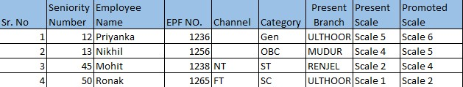

**Post Conditions:**

1. System should display the toaster message “Final Promotion List submitted successfully”.
2. System should send the details for Approval as per the defined workflow.
3. Upon final approval as per the workflow defined, Promotion Letter should be generated.
4. After final approval, the system should check which scale and stage the promoted employee currently exists in and to which scale they are being promoted.
5. The system should maintain an audit trail of configuration changes for accountability and compliance purposes.
6. The system should maintain historical eligibility data for reporting or auditing purposes.

**Workflow:**

1. HO AM/M CORE PHRDD→ HO SM CORE PHRDD→ HO CM PHRDD

**Workflow Explanation:**

Step 1 – The HO AM/M CORE PHRDD will upload the final promotion list and submit it.

Step 2 – The HO SM CORE PHRDD will receive a task notification to review the request and approve or reject it.

* Upon Approval - It will be passed on to HO CM PHRDD for review, and further, it will be approved or rejected by HO CM PHRDD.
* Upon Rejection – The requestor will be notified of the rejection, and the task will be terminated.
* Upon Resubmit - Go back to Step 1.

Step 3 – The HO CM PHRDD will receive a task notification to review the request and approve or reject the Man power Configuration request.

* Upon Approval - The task will be completed, and HO CM PHRDD will be notified of the approval.
* Upon Rejection – The requestor will be notified of the rejection, and the task will be terminated.
* Upon Resubmit – Go back to Step 1.

**Business Rules and Validation:**

1. System should not upload the file if the file are not the above format.
2. In case if file in not in proper format, System should throw an error message “Please upload the file in the correct format”.
3. The system should validate whether an employee is receiving a promotion from a scale above the 3rd level. If the promotion is from the 3rd scale or below, the 'Channel' and 'Category' fields are required.
   1. For Example: - if a candidate from scale 2nd is promoted for scale 3rd, there channel and category are mandatory in above excel.
4. However, if the promotion is from a scale above the 3rd level, the 'Channel' and 'Category' fields should not be mandatory.
5. For Example: - if a candidate from scale 3rd is promoted for scale 4th, there channel and category are not required.
6. If the user has not uploaded the file according to the Mitra Committee report, the system should display a pop-up message: “This does not adhere to the Mitra Committee report. You are promoting the staff beyond the recommended level. Do you still want to proceed?” with yes and No button. In case if user clicks on Yes, the file should be processed for the approval. Otherwise, the user should re-upload the file.
7. For Example: - if there is only 5 officers required to promotion from scale 4 to scale 5 in any category, and user are uploading 6 officer in final promotion list, then the system should display a pop-up message: “*This does not adhere to the Mitra Committee report. You are promoting the employee beyond the recommended level. Do you still want to proceed?”* with **yes** and **No**button. In case if user clicks on Yes, the file should be processed for the approval. Otherwise, the user should re-upload the file.
8. If staff receives a promotion to multiple level, the system should display an error message: “<Employee Name/ EPF Number >is being promoted for multiple level.” After closing the pop-up widow system should redirect on the Upload final Promotion list.
9. For example, if an officer is currently at scale 3 and is being promoted to scale 5, the system should display an error message: “<Officer Name/ EPF Number > is being promoted for multiple level.”
10. If details of staff in uploaded excel is not as per user details in master data, system should pop up an error message stating “<Employee Name/ EPF Number> Details in uploaded excel is not matching with the user details in master data”. After closing the pop-up widow system should redirect on the Upload final Promotion list.

**Assumptions:**

1. Only the Active and authorised user can upload the final promotion report.
2. User can upload the final promotion report in November or December.

**Constraints:** NIL

#### Functional User stories for Final Promotion List

|  |  |  |  |  |
| --- | --- | --- | --- | --- |
| **Id** | **Functionality** | **Role** | **Description** | **Acceptance criteria/ Remarks** |
| FPL-01 | FPL-Approval | HO SM CORE PHRDD | As a HO SM CORE PHRDD, I should be able to approve, reject and resubmit with remarks. |  |
| FPL-02 | FPL-Approval | HO CM PHRDD | As a HO CM PHRDD, I should be able to approve, reject and resubmit with remarks. |  |
| FPL-03 | View FPL List | HO AM/M CORE PHRDD, HO SM CORE PHRDD, HO CM PHRDD | As a user, I should be able to view all the Final promotion lists. |  |

#### Use Case: Generate Promotion Intimation letter for the promoted employee

**Definition: -** A "Promotion Intimation Letter" is a formal communication issued by human resources department to an employee to formally announce and convey information about their promotion within the organization. This letter serves to inform the employee of their new position, responsibilities, and any relevant details associated with the promotion.

**Purpose:** The Promotion Intimation Letter serves several important purposes within an organization. Its primary goal is to formally communicate the promotion of an employee and provide essential information about the new role.

**Goal of Requirement:** System should generate a List of employee who is eligible for promotion according to business rules.

**User: -** HO AM/M CORE PHRDD, HO SM CORE PHRDD, HO CM PHRDD

**Pre-conditions:**

1. User should be the permanent staff.
2. User shouldn’t be resigned, exited, suspended, retired, disable.
3. Promotion intimation letter should be generate after approval uploading the final list of promotion.
4. This letter should be generate according to Employee.

**Example**: If there are five candidates who are getting promotion, then it is appropriate to generate five promotion intimation letters, each addressed to the respective candidate. Each promotion intimation letter should contain the specific details relevant to the individual employee's.

**Basic Flow:**

1. User logs into the HRMS solution successfully.
2. User navigates to the Transfer and Promotion from menu and upon click on Generate Promotion Intimation Letter.

* System should show list of existing and generated Promotion Intimation letter for previous year.
* System should show a global icon button ‘Generate promotion intimation letter’.

1. Upon click of the global icon button by the user

* System should generate the promotion letter for the current year.
* System should consider the Calculations, logics, conditions, and rules as listed below in Business Rules and Validation section.

**Post Conditions:**

1. System should save the Promotion Intimation letter and display in the list screen of ‘Promotion intimation letter’.
2. Applicable for Staff been promoted to Branch Office/ Regional Office: After the approval of final promotion list, an automatic generation of a promotion letter will occur. This letter will be sent as an email attachment to the respective staff. Additionally, the Branch office and Regional office of both the current and proposed placement branches will receive the same email notification.

**Note**: if Staff Don’t have email id, email should be directed to BM of current branch where staff is working.

1. Applicable for Staff been promoted to Head Office: After the approval of final promotion list, Promotion Letter will be automatically generated and sent as an email attachment to the respective staff. Simultaneously, this email will also be received by the Head of Division (CM) of the proposed posting division in Head Office. Sample of Administrative Orders is provided below for reference.

**Note**: if Staff don’t have email id, email should sent to the Head of Division (CM) of the proposed posting division in Head Office.

1. After the approval of final promotion list, the system should inform the payroll module about the new salary basis for the staff. The new basis salary should be calculated from the date of the promotion.

**Example**: if an officer receives a promotion from scale 2, stage 1 to scale 3, stage 1 on December 15, 2023, then their basic pay will change from ₹ 36,000.00 at scale 2, stage 1 to ₹ 48,170.00 at scale 3, stage 1, and effective from December 15, 2023. Before December 15 2023 his basic pay will ₹ 36,000.00.

1. The promotion details should be reflected in the user profile. These details should also be updated in the Employee Master.
2. User can download and print the promotion intimation letter.

**Business Rules and validations:**

1. As per the format below details needs to be displayed.

|  |
| --- |
|  |

1. After promotion, system should display the Basic salary as per fitment matrix and Next date of increment according to the promotion fitment matrix which is defined in below.
2. **Office Attender to Office Assistant**

|  |  |  |  |  |  |  |
| --- | --- | --- | --- | --- | --- | --- |
| **Before Promotion** | | | **After promotion** | | | |
| **Stage Name of Sub Staff (Office Attendant)** | **Stage of Sub-staff Grade  (Office Attendant)** | **Basic Pay in Sub-Staff Grade** | **Clubbing Stages** | **Stage of Clerical Cadre  (Office Assistant)** | **Basic Pay in Clerical Cadre** | **Next Date of Increment** |
| **General  Increments** | 1 | ₹ 14,500.00 | Lower Clubbed Stage | 1 | ₹ 17,900.00 | Anniversary Date of Promotion |
| 2 | ₹ 15,000.00 | Higher Clubbed Stage | 1 | ₹ 17,900.00 | Anniversary Date of Increment in Sub Staff Grade |
| 3 | ₹ 15,500.00 | Lower Clubbed Stage | 2 | ₹ 18,900.00 | Anniversary Date of Promotion |
| 4 | ₹ 16,000.00 | Higher Clubbed Stage | 2 | ₹ 18,900.00 | Anniversary Date of Increment in Sub Staff Grade |
| 5 | ₹ 16,500.00 | Lower Clubbed Stage | 3 | ₹ 19,900.00 | Anniversary Date of Promotion |
| 6 | ₹ 17,115.00 | Higher Clubbed Stage | 3 | ₹ 19,900.00 | Anniversary Date of Increment in Sub Staff Grade |
| 7 | ₹ 17,730.00 | Lower Clubbed Stage | 4 | ₹ 20,900.00 | Anniversary Date of Promotion |
| 8 | ₹ 18,345.00 | Higher Clubbed Stage | 4 | ₹ 20,900.00 | Anniversary Date of Increment in Sub Staff Grade |
| 9 | ₹ 18,960.00 | Lower Clubbed Stage | 5 | ₹ 22,130.00 | Anniversary Date of Promotion |
| 10 | ₹ 19,575.00 | Higher Clubbed Stage | 5 | ₹ 22,130.00 | Anniversary Date of Increment in Sub Staff Grade |
| 11 | ₹ 20,315.00 | NA | 6 | ₹ 23,360.00 | Anniversary Date of Promotion |
| 12 | ₹ 21,055.00 | Lower Clubbed Stage | 7 | ₹ 24,590.00 | Anniversary Date of Promotion |
| 13 | ₹ 21,795.00 | Higher Clubbed Stage | 7 | ₹ 24,590.00 | Anniversary Date of Increment in Sub Staff Grade |
| 14 | ₹ 22,535.00 | Lower Clubbed Stage | 8 | ₹ 26,080.00 | Anniversary Date of Promotion |
| 15 | ₹ 23,405.00 | Higher Clubbed Stage | 8 | ₹ 26,080.00 | Anniversary Date of Increment in Sub Staff Grade |
| 16 | ₹ 24,275.00 | NA | 9 | ₹ 27,570.00 | Anniversary Date of Promotion |
| 17 | ₹ 25,145.00 | Lower Clubbed Stage | 10 | ₹ 29,060.00 | Anniversary Date of Promotion |
| 18 | ₹ 26,145.00 | Higher Clubbed Stage | 10 | ₹ 29,060.00 | Anniversary Date of Increment in Sub Staff Grade |
| 19 | ₹ 27,145.00 | NA | 11 | ₹ 30,550.00 | Anniversary Date of Promotion |
| 20 | ₹ 28,145.00 | Lower Clubbed Stage | 12 | ₹ 32,280.00 | Anniversary Date of Promotion |
| **Stagnation Increments** | 21*,22* | ₹ 29,145.00 | Higher Clubbed Stage | 12 | ₹ 32,280.00 | Anniversary Date of Increment in Sub Staff Grade |
| 23*,24* | ₹ 30,145.00 | Lower Clubbed Stage | 13 | ₹ 34,010.00 | Anniversary Date of Promotion |
| 25*,26* | ₹ 31,145.00 | Higher Clubbed Stage | 13 | ₹ 34,010.00 | Anniversary Date of Increment in Sub Staff Grade |
| 27*,28* | ₹ 32,145.00 | Lower Clubbed Stage | 14 | ₹ 35,740.00 | Anniversary Date of Promotion |
| 29*,30* | ₹ 33,145.00 | Higher Clubbed Stage | 14 | ₹ 35,740.00 | Anniversary Date of Increment in Sub Staff Grade |
| 31*,32* | ₹ 34,145.00 | Lower Clubbed Stage | 15 | ₹ 37,470.00 | Anniversary Date of Promotion |
| 33*,34* | ₹ 35,145.00 | Higher Clubbed Stage | 15 | ₹ 37,470.00 | Anniversary Date of Increment in Sub Staff Grade |
| 35*,36* | ₹ 36,145.00 | NA | 16 | ₹ 39,200.00 | Anniversary Date of Promotion |
| 37*,38* | ₹ 37,145.00 | NA | 17 | ₹ 40,930.00 | Anniversary Date of Promotion |

1. The above fitment of salary on promotion to clerical cadre at the clubbing stages, the employee.
2. In the lower clubbed stage of clerical scale of Pay will get their next increment after promotion on the anniversary date of promotion.
3. In higher clubbed stage, their increment after promotion shall be the anniversary date of their last increment in subordinate cadre.

**Note:** Promoted employee who are drawing Fixed Personal Pay in terms of Settlement may continue to draw the same quantum of Fixed Personal Pay even after promotion which shall remain unaltered till revised. After completion of one year of the promoted cadre/scale, he shall be sanctioned FPP as applicable to the higher cadre/scale in which he is placed.

**Example**: if a candidate get 12000 Fixed Personal Pay in (Office Attendant) cadre that should be continue to draw the same quantum of Fixed Personal Pay even after promotion which shall remain unaltered till revised. Otherwise FPP should be change after completion of one year of the promoted cadre/scale (Office Assistant).

1. **Office Assistant to Scale I**

|  |  |  |  |  |  |
| --- | --- | --- | --- | --- | --- |
| **Before Promotion** | | | **After promotion** | | |
| **Stage Name of Clerical Cadre (Office Assistant)** | **Stage of Clerical Cadre  (Office Assistant)** | **Basic Pay in Clerical cadre (Office Assistant)** | **Stage of Scale I** | **Basic Pay in Scale I** | **Next Date of Increment** |
| **General  Increments** | 1 | ₹ 17,900.00 | 1 | ₹ 36,000.00 | **For next date of increment please follow the below business rules.** |
| 2 | ₹ 18,900.00 | 1 | ₹ 36,000.00 |
| 3 | ₹ 19,900.00 | 1 | ₹ 36,000.00 |
| 4 | ₹ 20,900.00 | 1 | ₹ 36,000.00 |
| 5 | ₹ 22,130.00 | 1 | ₹ 36,000.00 |
| 6 | ₹ 23,360.00 | 1 | ₹ 36,000.00 |
| 7 | ₹ 24,590.00 | 1 | ₹ 36,000.00 |
| 8 | ₹ 26,080.00 | 1 | ₹ 36,000.00 |
| 9 | ₹ 27,570.00 | 1 | ₹ 36,000.00 |
| 10 | ₹ 29,060.00 | 2 | ₹ 37,490.00 |
| 11 | ₹ 30,550.00 | 3 | ₹ 38,980.00 |
| 12 | ₹ 32,280.00 | 4 | ₹ 40,470.00 |
| 13 | ₹ 34,010.00 | 5 | ₹ 41,960.00 |
| 14 | ₹ 35,740.00 | 6 | ₹ 43,450.00 |
| 15 | ₹ 37,470.00 | 7 | ₹ 44,940.00 |
| 16 | ₹ 39,200.00 | 8 | ₹ 46,430.00 |
| 17 | ₹ 40,930.00 | 9 | ₹ 48,170.00 |
| 18 | ₹ 42,660.00 | 10 | ₹ 49,910.00 |
| 19 | ₹ 45,930.00 | 11 | ₹ 51,900.00 |
| 20 | ₹ 47,920.00 | 12 | ₹ 53,890.00 |
| **Stagnation Increments** | +1 | ₹ 49,910.00 | 13 | ₹ 55,880.00 |
| +2 | ₹ 51,900.00 | 14 | ₹ 57,870.00 |
| +3 | ₹ 53,890.00 | 15 | ₹ 59,860.00 |
| +4 | ₹ 55,880.00 | 16 | ₹ 61,850.00 |
| +5 | ₹ 57,870.00 | 17 | ₹ 63,840.00 |
| +6 | ₹ 59,860.00 | 17 | ₹ 63,840.00 |
| +7 | ₹ 61,850.00 | 17 | ₹ 63,840.00 |
| +8 | ₹ 63,840.00 | 17 | ₹ 63,840.00 |
| +9 | ₹ 65,830.00 | 17 | ₹ 63,840.00 |

1. From 1st to 19th stage
2. If a candidate drawing a basic pay between the 1st to 9th stage in the clerical scale given in the above table, will be fitted at the minimum of the Officers' Scale and will draw their next increment on the anniversary date of promotion.

**Example**: if a candidate is in 7th stage his basic pay is ₹ 24,590.00 and he got promotion now his basic pay will 36,000.00 and the date of their next increment will be the anniversary date of promotion.

1. If a candidate drawing a basic pay between the 10th to 19th stage in the clerical scale given in the above table, will be fitted as per the matrix above of the Officers' Scale and will draw their next increment on the Anniversary Date of Increment in Clerical Cadre (Office Assistant).

**Example**: if a candidate is in 17th stage his basic pay is ₹ 40,930.00 and he got promotion now his basic pay will 48,170.00 and the date of their next increment on Anniversary Date of Increment in Clerical Cadre (Office Assistant).

1. From 20th to +4 stage
2. The candidate who have completed more than one year at basic pay of 47920, 49910, 51900, 53890 and 55880 will draw their next increment on the anniversary date of their last increment in the clerical cadre.

**Example**: if a candidate those Basic pay 49,910.00 is started from 01- April-2023 and the get promotion at 1-May -2023, now his basic pay will 55,880.00 and the date of their next increment on Anniversary Date of Increment in Clerical Cadre (Office Assistant).

1. The candidate who have completed less than one year at basic pay of 47,920, 49,910, 51,900, 53890 and 55880 will draw their next increment after fitment, on the anniversary date of promotion and thereafter draw their annual increments every year on the same date.

**Example**: if a candidate those Basic pay 49,910.00 is started from 01- April-2023 and the get promotion at 1-March-2023, now his basic pay will 55,880.00 and the date of their next increment on Anniversary Date of Promotion.

1. From +5 to +9 stage
2. The candidate who have completed more than one year at basic pay of 57870, 59860 and 61850 will be given fitment in the Officers' Scale at 63840 and will earn their next increment on the anniversary date of promotion.

**Example**: if a candidate those Basic pay 57,870.00 is started from 01- April-2023 and the get promotion at 1-May-2023, now his basic pay will 63,840.00 and the date of their next increment on Anniversary Date of Promotion.

1. The candidate who have completed more than one year at basic pay of ₹ 63,840.00 and ₹ 65,830.00 will be given fitment in the Officers' Scale at 63840 and will earn their next increment on the Anniversary Date of Increment in Clerical Cadre (Office Assistant).

**Example**: if a candidate those Basic pay 59,860.00 is started from 01- April-2023 and the get promotion at 1-March-2023, now his basic pay will 63,840.00 and the date of their next increment on Anniversary Date of Increment in Clerical Cadre (Office Assistant).

**Note 1:** Promoted employee who are drawing Fixed Personal Pay in terms of Settlement may continue to draw the same quantum of Fixed Personal Pay even after promotion which shall remain unaltered till revised. After completion of one year of the promoted cadre/scale, he shall be sanctioned FPP as applicable to the higher cadre/scale in which he is placed.

**Example**: if a candidate get 12000 Fixed Personal Pay in office assistant cadre that should be continue to draw the same quantum of Fixed Personal Pay even after promotion which shall remain unaltered till revised. Otherwise FPP should be change after completion of one year of the promoted cadre/scale.

**Note 2:** If Officer has passed JAIIB or CAIIB then he will get 1 advance increment for each, so when he is getting promoted from Office Assistant to Scale 1, scale 1,2,3,4 to Scale 2,3,4,5 respectively then to arrive the basic pay after promotion, we need to reduce the advance increments stages in the current scale and then need to fit in the fitment chart, and then for the arrived basic pay we need to add the increments as per the new scale (promoted scale) and consider that incremented Basic Pay.

**Note 3**: If despite the fitment as given above, the emoluments drawn as an officer on promotion are less than the emoluments drawn as a clerk, the difference may be protected by way of Temporary Adjustment Pay till the same is covered due to release of stagnation increments, to compensate the difference amount. This pay will rank for dearness allowance and superannuation benefits.

**Example**: if candidate basis pay 65,830.00 now he got promotion now his new basic pay will be 63,840 which is less than emoluments drawn as an office assistant, now the difference of 1990 rupees will be protected by way of Temporary Adjustment Pay till the same is covered due to release of stagnation increments, to compensate the difference amount.

**Note 4:** If an employee has passed CAIIB after reaching the 20th stage of the clerical cadre and promoted to Officers' scale subsequently, he/she shall be granted one increment for passing JAIIB and another increment for passing CAIIB after fitment in Officers' scale as per his/her clerical stage of pay before promotion.

**Example**: if a candidate is on the 20th stage and has passed his JAIIB and CAIIB exams, and subsequently receives a promotion, he will be eligible for two increments after the promotion.

**Note 5:** Please take FPP and PQP reference from Payroll module.

**Important Note**: If the promote officer has passed JAIIB or CAIIB at the time of his promotion, notional basic pay will be arrived at after Reducing the increments earned for passing JAIIB/CAIIB, from the clerical basic pay. He shall then be fitted in the officers’ Scale in accordance with the above table and appropriate one or two increments in the Officers’ Scale shall be added with basic pay so fixed.

1. **Scale I to Scale II**

|  |  |  |  |  |  |
| --- | --- | --- | --- | --- | --- |
| **Before Promotion** | | | **After Promotion** | | |
| **Stage Name of Scale I** | **Stage of Scale I** | **Basic Pay in Scale I** | **Stage of Scale II** | **Basic Pay in Scale II** | **Next Date of Increment** |
| **General Increments** | 1 | ₹ 36,000.00 | 1 | ₹ 48,170.00 | **For next date of increment please follow the below business rules** |
| 2 | ₹ 37,490.00 | 1 | ₹ 48,170.00 |
| 3 | ₹ 38,980.00 | 1 | ₹ 48,170.00 |
| 4 | ₹ 40,470.00 | 1 | ₹ 48,170.00 |
| 5 | ₹ 41,960.00 | 1 | ₹ 48,170.00 |
| 6 | ₹ 43,450.00 | 1 | ₹ 48,170.00 |
| 7 | ₹ 44,940.00 | 1 | ₹ 48,170.00 |
| 8 | ₹ 46,430.00 | 1 | ₹ 48,170.00 |
| 9 | ₹ 48,170.00 | 2 | ₹ 49,910.00 |
| 10 | ₹ 49,910.00 | 3 | ₹ 51,900.00 |
| 11 | ₹ 51,900.00 | 4 | ₹ 53,890.00 |
| 12 | ₹ 53,890.00 | 5 | ₹ 55,880.00 |
| 13 | ₹ 55,880.00 | 6 | ₹ 57,870.00 |
| 14 | ₹ 57,870.00 | 7 | ₹ 59,860.00 |
| 15 | ₹ 59,860.00 | 8 | ₹ 61,850.00 |
| 16 | ₹ 61,850.00 | 9 | ₹ 63,840.00 |
| 17 | ₹ 63,840.00 | 10 | ₹ 65,830.00 |
| **Sliding Increments** | +1 | ₹ 65,830.00 | 11 | ₹ 67,820.00 |
| +2 | ₹ 67,820.00 | 12 | ₹ 69,810.00 |
| +3 | ₹ 69,810.00 | 13 | ₹ 71,800.00 |
| **Stagnation Increments** | ++1 | ₹ 71,800.00 | 14 | ₹ 73,790.00 |
| ++2 | ₹ 73,790.00 | 15 | ₹ 76,010.00 |
| ++3 | ₹ 76,010.00 | 16 | ₹ 78,230.00 |
| ++4 | ₹ 78,230.00 | 17 | ₹ 80,450.00 |
| ++5 | ₹ 80,450.00 | 17 | ₹ 80,450.00 |

1. **Scale II to Scale III**

|  |  |  |  |  |  |
| --- | --- | --- | --- | --- | --- |
| **Before Promotion** | | | **After Promotion** | | |
| **Stage Name of Scale II** | **Stage of Scale II** | **Basic Pay in Scale II** | **Stage of Scale III** | **Basic Pay in Scale III** | **Next Date of Increment** |
| **General Increment** | 1 | ₹ 48,170.00 | 1 | ₹ 63,840.00 | **For next date of increment please follow the below business rules** |
| 2 | ₹ 49,910.00 | 1 | ₹ 63,840.00 |
| 3 | ₹ 51,900.00 | 1 | ₹ 63,840.00 |
| 4 | ₹ 53,890.00 | 1 | ₹ 63,840.00 |
| 5 | ₹ 55,880.00 | 1 | ₹ 63,840.00 |
| 6 | ₹ 57,870.00 | 1 | ₹ 63,840.00 |
| 7 | ₹ 59,860.00 | 1 | ₹ 63,840.00 |
| 8 | ₹ 61,850.00 | 1 | ₹ 63,840.00 |
| 9 | ₹ 63,840.00 | 2 | ₹ 65,830.00 |
| 10 | ₹ 65,830.00 | 3 | ₹ 67,820.00 |
| 11 | ₹ 67,820.00 | 4 | ₹ 69,810.00 |
| 12 | ₹ 69,810.00 | 5 | ₹ 71,800.00 |
| **Sliding Increments** | +1 | ₹ 71,800.00 | 6 | ₹ 73,790.00 |
| +2 | ₹ 73,790.00 | 7 | ₹ 76,010.00 |
| +3 | ₹ 76,010.00 | 8 | ₹ 78,230.00 |
| +4 | ₹ 78,230.00 | 8 | ₹ 78,230.00 |
| **Stagnation Increments** | ++1 | ₹ 80,450.00 | 9 * | ₹ 80,450.00 |
| ++2 | ₹ 82,670.00 | 12 * | ₹ 82,670.00 |
| ++3 | ₹ 84,890.00 | 13 * | ₹ 84,890.00 |
| ++ 4 | ₹ 87,110.00 | 16 * | ₹ 87,110.00 |
| ++5 | ₹ 89,330.00 | 18 * | ₹ 89,610.00 |

**Note:** Those who are getting promoted to scale III after reaching the Basic pay of 87110/- their next stagnation increment will be released on the date it was due in the earlier grade i.e. Scale II

1. **Scale III to Scale IV**

|  |  |
| --- | --- |
| **Before Promotion** | **After Promotion** |

|  |  |  |  |  |  |
| --- | --- | --- | --- | --- | --- |
| **Stage Name of Scale III** | **Stage of Scale III** | **Basic Pay in Scale III** | **Stage of Scale IV** | **Basic Pay in Scale IV** | **Next Date of Increment** |
| **General Increments** | 1 | ₹ 63,840.00 | 1 | ₹ 76,010.00 | **For next date of increment please follow the below business rules** |
| 2 | ₹ 65,830.00 | 1 | ₹ 76,010.00 |
| 3 | ₹ 67,820.00 | 1 | ₹ 76,010.00 |
| 4 | ₹ 69,810.00 | 1 | ₹ 76,010.00 |
| 5 | ₹ 71,800.00 | 2 | ₹ 78,230.00 |
| 6 | ₹ 73,790.00 | 3 | ₹ 80,450.00 |
| 7 | ₹ 76,010.00 | 4 | ₹ 82,670.00 |
| 8 | ₹ 78,230.00 | 5 | ₹ 84,890.00 |
| **Stagnation Increments** | ++1 | ₹ 80,450.00 | 6 | ₹ 87,390.00 |
| ++2 | ₹ 82,670.00 | 7 | ₹ 89,890.00 |
| ++3 | ₹ 84,890.00 | 8 * | ₹ 89,890.00 |
| ++4 | ₹ 87,110.00 | 8 * | ₹ 89,890.00 |
| ++5 | ₹ 89,610.00 | 8 * | ₹ 89,890.00 |
| ++6 | ₹ 92,110.00 | 10* | ₹ 92,390.00 |

1. **Scale IV to Scale V**

|  |  |
| --- | --- |
| **Before Promotion** | **After Promotion** |

|  |  |  |  |  |  |
| --- | --- | --- | --- | --- | --- |
| **Stage Name of Scale IV** | **Stage of Scale IV** | **Basic Pay in Scale IV** | **Stage of Scale V** | **Basic Pay in Scale V** | **Next Date of Increment** |
| **General Increments** | 1 | ₹ 76,010.00 | 1 | ₹ 89,890.00 | **For next date of increment please follow the below business rules** |
| 2 | ₹ 78,230.00 | 1 | ₹ 89,890.00 |
| 3 | ₹ 80,450.00 | 1 | ₹ 89,890.00 |
| 4 | ₹ 82,670.00 | 1 | ₹ 89,890.00 |
| 5 | ₹ 84,890.00 | 2 | ₹ 92,390.00 |
| 6 | ₹ 87,390.00 | 3 | ₹ 94,890.00 |
| 7 | ₹ 89,890.00 | 4 | ₹ 97,620.00 |
| **Stagnation Increments** | ++1 | ₹ 92,390.00 | 5 | ₹ 1,00,350.00 |  |
|  | ++2 | ₹ 95,120.00 | 5 | ₹ 1,00,350.00 |  |

1. **Scale V to Scale VI**

|  |  |
| --- | --- |
| **Before Promotion** | **After Promotion** |

|  |  |  |  |  |  |
| --- | --- | --- | --- | --- | --- |
| **Stage Name of Scale V** | **Stage of Scale V** | **Basic Pay in Scale V** | **Stage of Scale VI** | **Basic Pay in Scale VII** | **Next Date of Increment** |
| **General Increments** | 1 | ₹ 89,890.00 | 1 | ₹ 1,04,240.00 | **For next date of increment please follow the below business rules.** |
| 2 | ₹ 92,390.00 | 1 | ₹ 1,04,240.00 |
| 3 | ₹ 94,890.00 | 1 | ₹ 1,04,240.00 |
| 4 | ₹ 97,620.00 | 2 | ₹ 1,07,210.00 |
| 5 | ₹ 1,00,350.00 | 3 | ₹ 1,10,180.00 |
| **Stagnation Increments** | ++1 | ₹ 1,03,320.00 | 4 | ₹ 1,10,180.00 |

1. **Applicable for all scales:**
2. At the time of fitment, if the promoted officer is get higher scale of pay the number of increments he had earned, we need to reduce the advance increments stages in the current scale and then need to fit in the fitment chart, and then for the arrived basic pay we need to add the increments as per the new scale (promoted scale) and consider that incremented Basic Pay.
3. In case if the stagnation at the maximum stage of the scale is less than one year, the officer should not be draw any Professional Qualification Pay. Then the number of increments i.e., one increment for JAIIB/ CAIIB as the case may be, included in his Basic Pay shall be reduced in the existing scale.
4. If the stagnation at the maximum stage of the scale is for a year or more but for less than 2 year then the officer should be draw a Professional Qualification Pay of   
   1020.

* In such cases, if he had passed both JAIIB and CAIIB before the date of promotion then one increment shall be reduced in the existing scale.
* If however, such Professional Qualification Pay of 1020 is for JAIIB only then there is no need to reduce increment from the existing scale.

1. If the stagnation at the maximum of the scale is for 2 year or more, the officer who has passed both JAIIB/CAIIB before the date of promotion, a Professional Qualification Pay of 2550 should be draw.
2. In this case there is no need to reduce increment for JAIIB and CAIIB as even without CAIIB increments the officer would be at the maximum of the scale.
3. After effecting the above adjustments the fitment of basic pay in the promoted scale will be made as per the fitment chart enclosed. The fixation so arrived at will be the basic pay in the promoted scale as on the date of promotion.
4. In case if an officer has reached the maximum stage in the previous (pre-promoted) scale of pay or on promotion gets an increase in the Basic Pay equivalent to two or more increments in the previous (pre-promoted) scale of pay, the date of increment shall be the anniversary date of promotion.

**Example**: if a candidate from scale IV stage ++2 got promotion, now his new scale will be scale V and stage will also be V and the date of increment shall be the anniversary date of promotion.

**Example**: if a candidate from scale IV stage 3 got promotion, now his new scale will be scale V and stage will also be 1 and the date of increment shall be the anniversary date of promotion.

1. If the Basic Pay after reduction of JAIIB and CAIIB increments is not at the maximum, then the date of increment shall be the anniversary date of last increment.
   * 1. Provided further that if an officer who is in Scale I, II or III is promoted to higher scale after reaching the maximum in the previous (pre-promoted) Scale of pay but before drawing stagnation increment, the date of his increment in the higher scale shall be the anniversary date of promotion or due date of stagnation increment in the previous (pre-promoted) scale whichever is earlier.

**Example**: After successfully completing JAIIB and CAIIB, the candidate's basic pay increased from 67820.00 (Stage 11) to 71800.00 (+1) due to multiple Advance Increments. Following a promotion to Scale 3, two increments were deducted from the fitment matrix, resulting in a new basic pay of 69,810.00 (Stage 4). Subsequently, there was an increment of +2 from the fitment matrix, leading to a revised basic pay of 73,790.00 (Stage 6). The next increment will be due on the anniversary date of the last increment.

1. If an officer is moving from scale 2 to scale 3 without a promotion and is experiencing stagnation, there will be no increment in their basic pay. The next increment date will be the anniversary date of the last increment.

**Example**: if a candidate at scale II, stage ++2, receives a promotion, their basic pay will become 82670. After the promotion, their basic pay will remain unchanged, and the next increment date will be the anniversary date of the last increment.

1. After completion of 1 year after completion of all stagnation increments, as per the matrix he will get the FPP.

**Example**: If he has not reached completed the stagnation increments, then he will not be awarded with FPP but he will get 1 advance increment, and when he complete all stagnation increments, he will be awarded with the FPP component.

**Note:** Please take FPP and PQP reference from Payroll module.

**Assumptions:**

1. The system should generate promotion letters only for those employees whose names exist in the uploaded final promotion list.

**Constraints:**

1. System will not generate the promotion letter if the employee is not exist in the final promotion list.

**PS QUICK IT KVGB**

Signature: 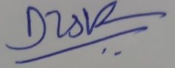 Signature __________________________

Name: Mr. Vijaya Kumar Devu__________ Name _____________________________

Title: Project Manager________________ Title ______________________________

Date: 21 December 2023______________ Date ______________________________

// End of the Document //