# Capios Improvements:

|  |  |  |  |
| --- | --- | --- | --- |
| **S.No** | **Feature** | **Referred From** | **Improvements fo Capios** |
| 1 | Selection of Text with more accuracy and better UX | OCR Editor | Selection of text is present. |
| 2 | View & Save all captured OCR snippets and view them in the popup in the same screen captured | - | Currently we are viewing the snippets in Dashboard. |
| 3 | Copy, Edit captured Text | OCR Editor |  |
| 4 | Download text in .doc, pdf, txt files | OCR Editor : [Link](https://chromewebstore.google.com/detail/ocr-editor-text-from-imag/ihnfmldlpdipgnliolhfffenpcmjgnif) |  |
| 5 | Extract Text from Video | DocSumo | Text is being extracted but not always accurate. |
| 6 | Auto Detect Language (All Languages) | DocSumo |  |
| 7 | Customizable settings -Text Box Size  -Separate Engines for more languages selection and alpha numeric OCR | Copyfish : [Link](https://chromewebstore.google.com/detail/copyfish-%F0%9F%90%9F-free-ocr-soft/eenjdnjldapjajjofmldgmkjaienebbj) |  |
| 8 | Capture text from Visible Part | DocSumo : [Link](https://chromewebstore.google.com/detail/docsumo-free-ocr-software/ihmmlfacoffajllfpdfkdikgmoogbnph) |  |

1. Selection of Text with more accuracy and better UX. Scales provided for accurate selection.

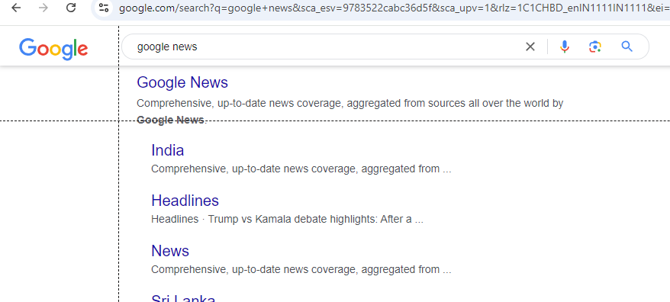

1. Copy, Edit captured Text

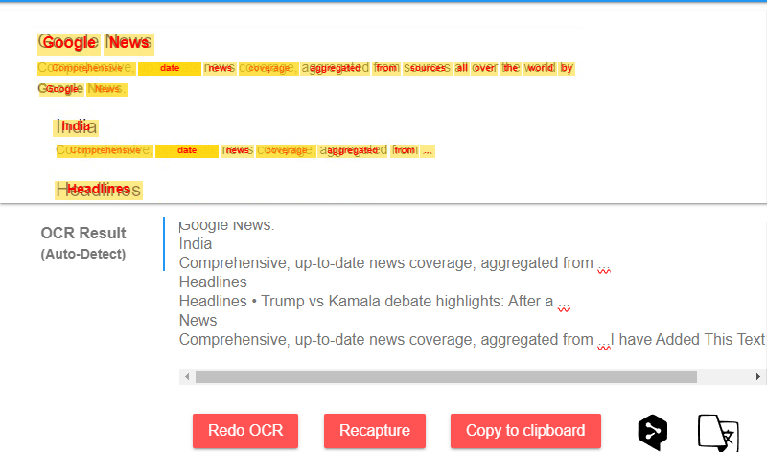

1. Download text in .doc, pdf, txt files

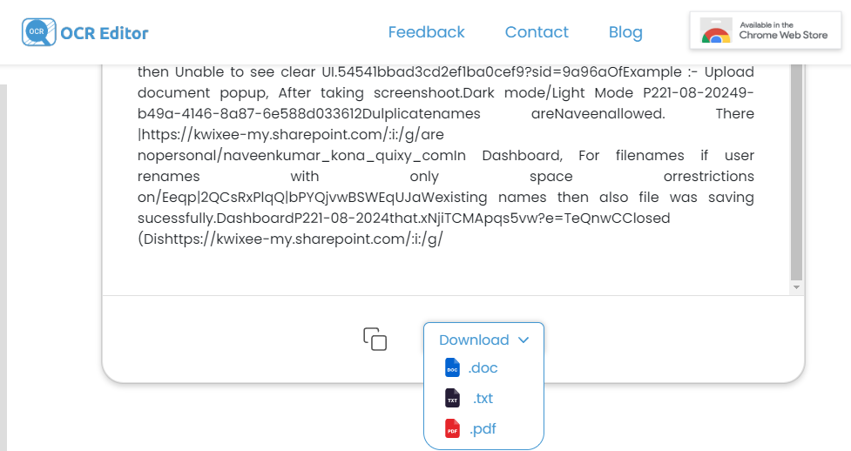

1. Extract Text from Video

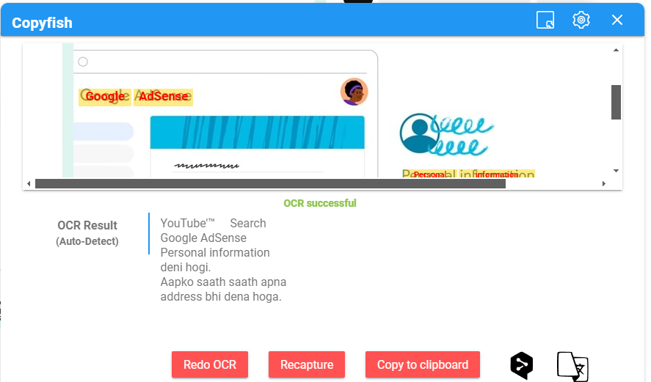

1. Auto Detect Language

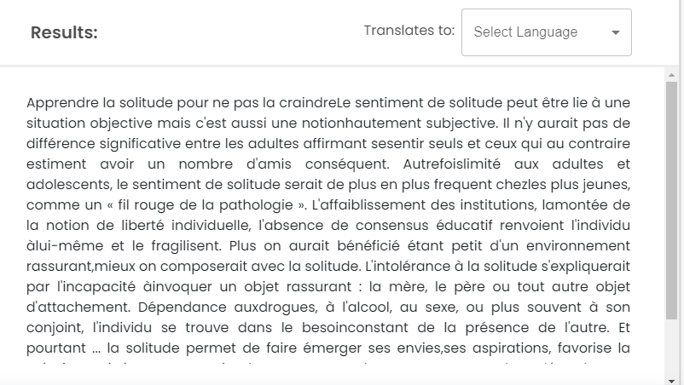

1. Customizable settings  
   -Text Box Size

-Separate Engines for more languages selection and alpha numeric OCR

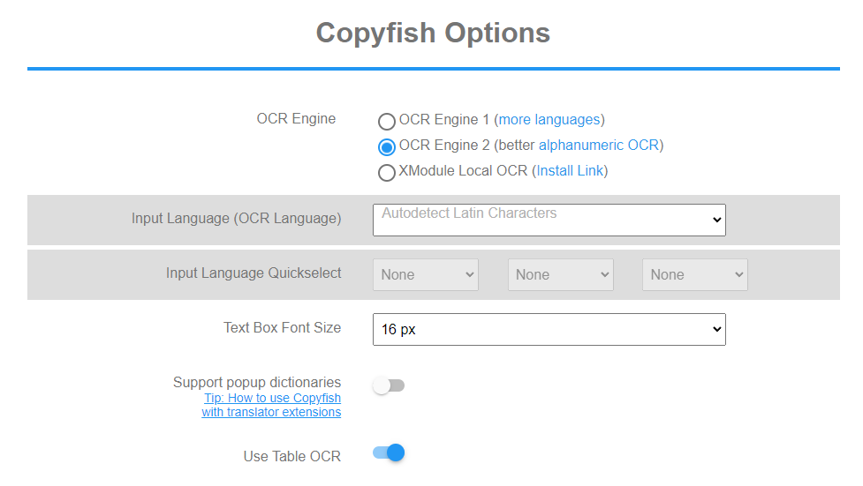

1. Capture text from Visible Part

