# **Improvements list for NLP Reporting**

## Improvement 1: Column Descriptions - Text areas for Input

### Description:

The inputs boxes to enter Column descriptions are very small. They should be text areas instead of text boxes.

Need to provide better User experience to provide column descriptions.

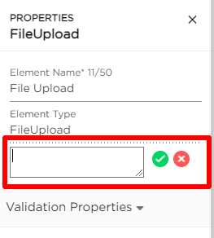

## Improvement 2: Table chart by default below any Graph type except Table charts

### Description:

As of now we are showing any chart based on prompt. We need to add a section below Graph to show the Table below. While getting the results show results in tabular form also along with graphical form.

## Improvement 3: Change Graph type

### Description:

There should be a way to change graph type after report is generated without change of prompt. Something like a dropdown to change type from One chart to other type.

## Improvement 4: Additional Prompts to retry or Modify results (Conversational)

### Description:

There is a way to Retry with additional prompt instructions in case or error or user want to get additional column in the result

Eg:

**Error:** Recreate report with last week tasks

**Request more data:** Add a column of subtasks in Report.

## Improvement 5: Additional Prompts for provided reports/charts

### Description:

There should be way to apply some actions on result - to ask questions on the result. To get insights on the result

***Eg:***

**Actions:**

Show me list of issues created by me in last 3 years.

Followup prompt: Show issues with High priority only.

**Insights:**

First Prompt: Show me list of all the bugs for project TSWC in last 3 months.

Followup prompt: What kind of bugs are most recurring

Improvement 6: Add new Chart Types

**Description:**

The following Chart types can be implemented for better representation of data for Comparisions.

* Stacked bar charts (for example to show improvements vs bugs in a sprint)
* Line chart
* Multiple line charts
* TBD on any other charts if required other than identified.

## Improvement 7: Error messages based on issue

**Description:**

Show proper error message if irrelevant query is given. Need to define/Categorize the error message based on context.